

**FACULTY OF COMPUTER SCIENCE & ENGINEERING**

**FINAL EXAM PROJECT**

**SOFTWARE DEVELOPMENT, OPERATION AND MAINTENANCE**

**TOPIC: SMART PRINTING SERVICES**

**STUDENT: BACH XUAN CANH - 81012202528**

**TA TRONG NGHIA - 81012202513**

**DOAN QUOC HUY - 81012202517**

**LE TIEN DAT - 81012202486**

**NGUYEN DINH DUY HAO - 81012202509**

**CLASS: 22DPM**

**LECTURER: MAI DUC TRUNG**

**SEMESTER 1, ACADEMIC YEAR 2024-2025**

## COMMITMENT

The project team hereby declares that all information and data in this Smart Printing Service project are true and collected responsibly and accurately. We have conducted all research and analysis carefully to ensure the reliability of the information we provide.

We hereby declare that the entire content of this project is our own creative effort and has not been copied from any other source without stating clearly. Any references or sources we use are clearly and transparently stated.

We also declare that this project does not violate any copyright or other intellectual property regulations. Any references or images used in this project are in compliance with copyright regulations and are used for fair purposes.

Finally, we assure that we have worked hard and invested a lot of effort into this project to achieve the best possible results.

## ACKNOWLEDGEMENTS

During the time studying and practicing the specialized project at Saigon International University, our group has received a lot of attention and help from Mr. Mai Duc Trung and friends. With the deepest and most sincere gratitude, we would like to send to Mr. Mai Duc Trung, Saigon International University, who, with his knowledge, experience and enthusiasm, has imparted to us valuable knowledge during the study period so that our group can complete the topic "Smart printing service". We would also like to thank the leadership of Saigon International University. With the limited time and experience of a student, this report is inevitably flawed. The group looks forward to receiving guidance and comments from teachers so that we can supplement, improve awareness, and better serve our practical work in the future.

I sincerely thank you!

## SCORE RULE

Họ và tên: Bạch Xuân Cảnh Lớp: 22DPM

Nhóm thực hiện (nếu có thì ghi họ tên của tất cả SV trong nhóm): Tạ Trọng Nghĩa, Đoàn Quốc Huy, Lê Tiến Đạt, Nguyễn Đình Duy Hạo

Tên Đồ án: Smart Printng Services

**Đánh giá**

|  |  |  |  |  |
| --- | --- | --- | --- | --- |
| **TT** | **Tiêu chí** | **Thang điểm** | **Điểm chấm** | **Ghi chú** |
| 1 | **Hình thức trình bày** |  |  |  |
|  | - Trình bày đúng quy định | 0.5 |  |  |
| - Không lỗi chính tả, lỗi trích dẫn tài liệu | 0.3 |  |  |
| - Trình bày đẹp, văn phong sáng | 0.2 |  |  |
| 2 | **Nội dung** |  |  |  |
|  | **Task 1.1**: Project overview | 1.5 |  | Trình bày rõ bối cảnh, mục tiêu, yêu cầu |
|  | **Task 1.2**: Functional/Non-functional reqs | 1 |  | Phân tích đầy đủ các yêu cầu |
|  | **Task 1.3**: Use Case Diagram và Scenario | 1 |  | Xây dựng sơ đồ UC và kịch bản chi tiết |
|  | **Task 2.1**: Activity diagram | 0.8 |  | Sơ đồ hoạt động đầy đủ, đúng logic |
|  | **Task 2.2**: Sequence diagram | 0.8 |  | Tương tác giữa các thành phần |
|  | **Task 2.3**: Class diagram | 0.8 |  | Thể hiện rõ mối quan hệ |
|  | **Task 2.4**: Develop MVP1 | 0.8 |  | Phát triển giao diện đơn giản |
|  | **Task 3.1**: Layered Architecture | 0.8 |  | Mô tả kiến trúc phân lớp |
|  | **Task 3.2**: UI, data, APIs | 0.8 |  | Lưu trữ dữ liệu, truy cập API |
|  | **Task 4.1**: Version control | 0.8 |  | Quản lý repository trực tuyến |
|  | **Task 4.2**: Adding documents/materials | 0.4 |  | Bổ sung tài liệu đầy đủ |
|  | **Task 4.3**: Usability testing | 0.8 |  | Kiểm thử tính khả dụng, phản hồi người dùng |
|  | **Task 5.1**: Develop MVP2 | 1 |  | Phát triển MVP2 từ phản hồi MVP1 |
| 3 | **TỔNG ĐIỂM** | 10 |  |  |

**Điểm chữ: ………………………………………………… (Làm tròn đến 1 số thập phân)**

**Giảng viên**

**Ths. Mai Đức Trung**

## INDEX

COMMITMENT 1

ACKNOWLEDGEMENTS 2

SCORE RULE 3

INDEX 4

PHOTO LIST 4

CHAPTER 1: OVERVIEW OF THE RESEARCH TOPIC 6

1. Introduction to research topic 6

2. Reason for choosing the topic 6

3. Object and scope of research 6

4. Research methods 8

5. Project results 8

CHAPTER 2: THEORETICAL BASIS 9

1. Introduction to DotNetFrameWork 9

2. Introduction to ASP.NET 9

3. MVC model 9

4. Topic Analysis with Draw.io 10

5. Git code management 10

6. Project management with trello 11

7. General USE CASE Diagram 13

8. USE CASE Description 13

9. Relationship diagram 25

11. Sequence Diagram 27

12. Class Diagram 28

13. Layered Architecture 29

14. UI/UX 31

CHAPTER 3: WEBSITE DEVELOPMENT 42

1. Request 42

2. Software interface 42

3. Testing 55

CHAPTER 4: CONCLUSION AND DEVELOPMENT DIRECTION 68

1. Conclude 68

2. Development direction 68

## PHOTO LIST

*Figure 1:*

*Figure 2:*

*Figure 3:*

*2.2.1. Login page interface*

*2.2.2. Forgot password interface*

*2.2.3. Home page interface*

*2.2.4. Document printing interface*

*2.2.5. Additional print page purchase interface*

*2.2.6. Payment interface*

*2.2.7. Admin home page interface*

*2.2.8. Printer management interface*

*2.2.9. Add printer interface*

*2.2.10. Printer editing interface*

*2.2.11. Printer details interface*

*2.2.12. Delete printer interface*

*2.2.13. Account management interface*

*2.2.14. Add new account interface*

*2.2.15. Edit account interface*

*2.2.16. Account details interface*

*2.2.17. Delete account interface*

*2.2.18. System configuration management interface*

*2.2.19. System Editing Interface*

*2.2.20. System Detail Interface*

*2.2.21. System Usage Report Management Interface*

*2.2.22. Report Detail Interface*

*2.2.23. Transaction History Management Interface*

*2.2.24. Transaction Editing Interface*

*2.2.25. Transaction Detail Interface*

## CHAPTER 1: OVERVIEW OF THE RESEARCH TOPIC

### 1. Introduction to research topic

This project aims to develop a comprehensive management software for smart printing services, aiming to improve operational efficiency and optimize workflows in organizations and businesses. The software will integrate modern functions such as remote printing management, setting up automatic printing modes based on usage needs, tracking the quantity and status of printing resources (ink, paper), as well as managing detailed reports on printing costs. In addition, the software also provides tools to control access, secure data, and optimize the allocation of printing resources, helping to minimize waste, save costs, and improve the user experience.

### 2. Reason for choosing the topic

In the context of increasing printing needs in businesses and organizations, traditional printing management based on manual methods or unsynchronized tools is revealing many limitations. These methods not only consume time and resources but also lead to waste of resources, lack of cost control, and potential risk of information loss.

Moreover, digital transformation in printing management has not been focused on, while this is a necessary solution to optimize operations, minimize operating costs, and improve work efficiency. A smart printing service system capable of integrating features such as remote printing management, printing process optimization, data security, and cost analysis will bring practical value in improving workflow and saving resources.

Therefore, the research and development of a smart printing service management software solution is urgent, to meet the needs of modernization, improve operational efficiency and optimize costs for businesses. This is not only a feasible direction to support digital transformation but also contributes to promoting sustainable development in the field of printing management.

### 3. Object and scope of research

* **Students:**

Those who need to print learning materials such as lectures, theses, reports, and reference materials during their studies.

* **Printing service managers:**

Those responsible for monitoring printing activities, managing equipment, supporting users, and ensuring the printing process is efficient.

**Scope of research:**

**About the content:**

Study the basic functions of Smart Print Service, including:

* **Print order management:**

Support students to place print orders via the application or website, allowing to customize parameters such as paper size, color, printing mode (single-sided, double-sided), and print quantity.

* **Print progress tracking:**

Provide information about print order status, expected completion, or notifications related to device errors or lack of resources.

* **Print resource management:**

Integrate a system to monitor paper usage, ink, and device status, making it easy for staff to check and replenish when needed.

* **Cost optimization:**

Support calculating costs for each print order, providing resource-saving options (such as black and white printing, draft printing) and exporting periodic cost reports.

* **Control and security:**

Authorize service usage, only allowing the orderer to receive printed documents, ensuring information security and avoiding waste.

* **Technical Support:**

Integrated online support channel helps students answer questions or handle problems that arise during the printing process.

**About time:**

- Study the printing process throughout the service lifecycle, from when students create a request, to when administrators process it, to when the document is completed.

**About space:**

- Focus on implementing the system at universities, libraries, or student printing centers.

- Evaluate the service's applicability in satellite areas, such as dormitories or branch campuses, to ensure convenience and efficiency.

### 4. Research methods

- Research and build websites with ASP.NET Core, C# language and My SQL.

### 5. Project results

**Perfecting the smart printing service software:**

- The software is designed, programmed and fully tested, fully meeting the proposed functions.

- The user interface is friendly, intuitive, suitable for students and printing service managers.

- The software operates stably on popular platforms, ensuring flexible deployment and easy expansion.

**Improving the efficiency of printing service management:**

- Automating the entire process from receiving print orders, processing orders, to returning results, minimizing manual work and increasing productivity for management staff.

- Students can place print orders online, track progress and receive notifications when documents are completed without having to wait long.

- Effectively manage print order queues, ensuring quick processing in a reasonable order and prioritizing when needed.

- Integrating printing cost reports, helping to transparently manage finances and optimize service usage budgets.

**Improve user experience and professionalism:**

- The software usage process is quick and convenient, meeting the printing needs of students and related subjects.

- Enhance printing information security, ensuring personal or sensitive documents are processed safely.

- Contribute to modernizing printing services in the school environment, bringing a better experience to users and improving service quality.

## CHAPTER 2: THEORETICAL BASIS

### 1. Introduction to DotNetFrameWork

DotNET Framework is a programming and application execution platform primarily on the Microsoft Windows operating system, developed by Microsoft from 2002 and ending in 2022 at version 4.8.1. It provides a software environment (CLR) for deploying programs, providing services such as software security, memory management and exception handling. .NET Framework includes large libraries that support the construction of software programs, including interface programming, database access, web applications, algorithms, data structures, network communication. It simplifies application writing by providing pre-designed components, and supports application construction with many tools, of which Microsoft's Visual Studio IDE is one of the important tools.

### 2. Introduction to ASP.NET

ASP.NET is a web development platform from Microsoft, first released in 2002. This platform is used to create web-based applications. ASP.NET supports many .NET programming languages ​​such as C#, VB.NET, J# and is designed to be compatible with the HTTP protocol, which is the standard protocol for web applications. The latest version of ASP.NET is 6.0.

* ASP stands for Active Server Pages, and .NET stands for Network Enabled Technologies.

### 3. MVC model

The MVC (Model-View-Controller) pattern is not just a theoretical concept but has become a standard in web application development. By dividing the application into three main components: Model, View and Controller, MVC improves maintainability and extensibility. The Model represents the data, the View displays the data to the user and the Controller handles user requests and updates the data. This pattern optimizes the efficiency of web application development and maintenance.

### 4. Topic Analysis with Draw.io

Draw.io (diagrams.net) is a flexible visualization tool, ideal for analyzing and designing systems, processes or ideas. With the ability to create a variety of diagrams such as mind maps, process maps, hierarchy charts or workflow charts, Draw.io offers outstanding benefits:

**Idea organization:** Easily analyze and organize key aspects of a topic.

**Process design:** Simulate steps and workflows to optimize operations.

**Visual documentation:** Create detailed, easy-to-understand documents to support the implementation process.

### 5. Git code management

Git is a prominent distributed version control system (DVCS) widely used in software development. Developed by Linus Torvalds (the father of Linux) in 2005, Git has become an indispensable tool for tracking, managing and collaborating on source code of projects from small to large.

**Figure 1:**

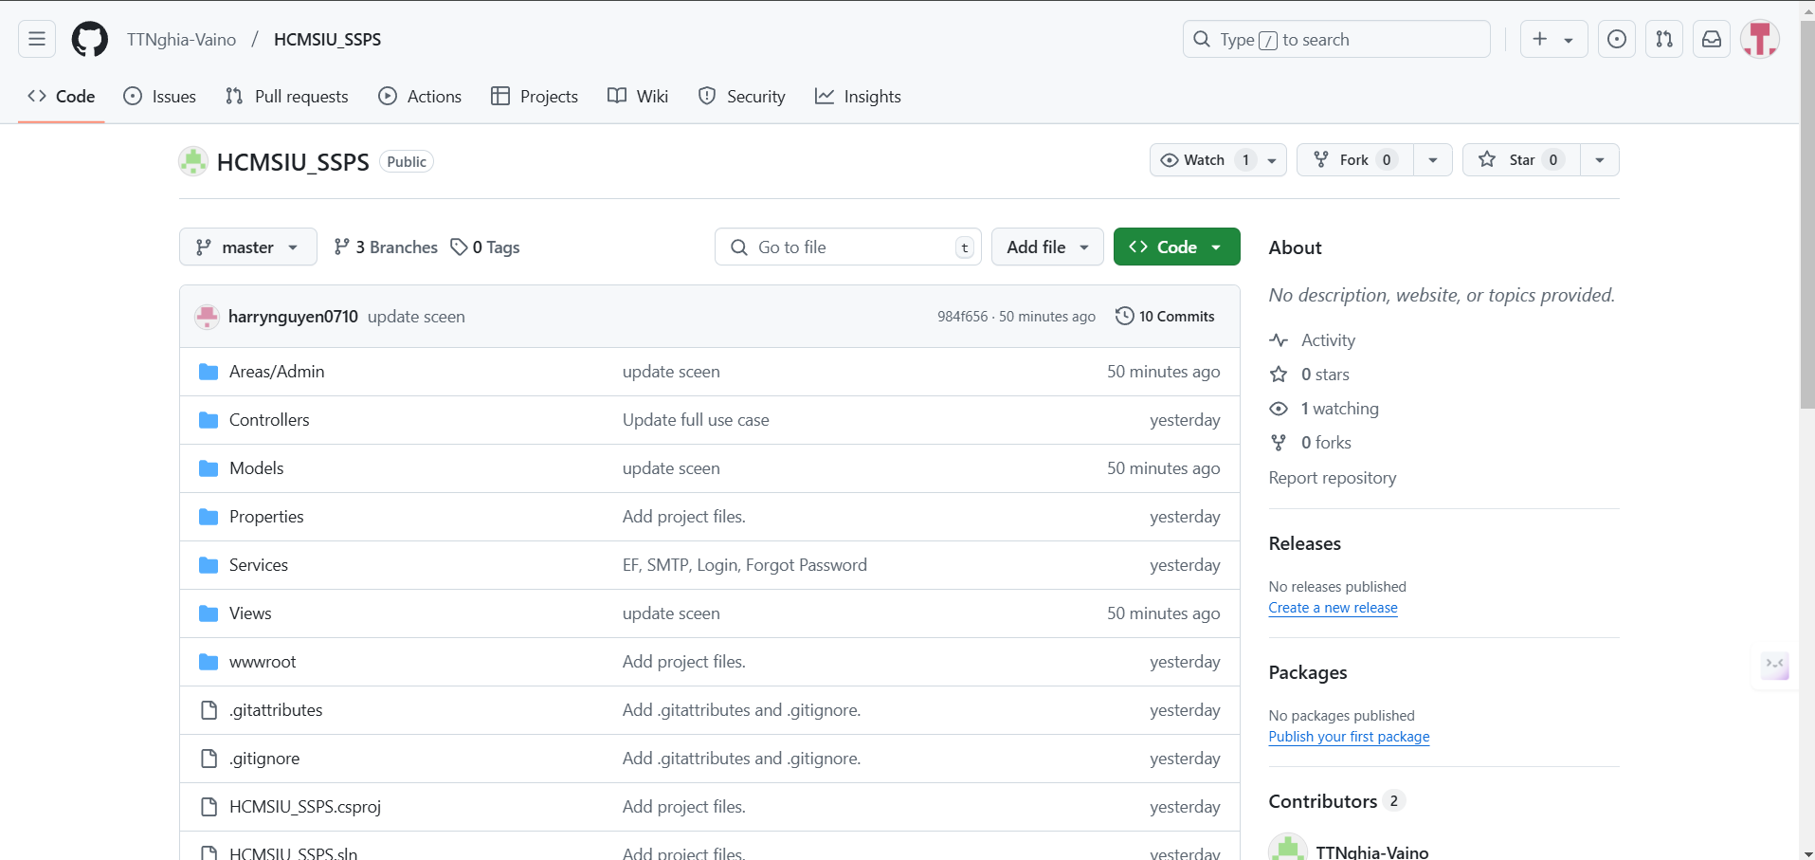

https://github.com/TTNghia-Vaino/HCMSIU_SSPS

### 6. Project management with trello

Trello is a web-based project and task management tool that helps organize and track tasks visually. It was developed by Atlassian and uses a simple yet effective interface, based on the Kanban method, to manage workflows.

**Figure 2:**

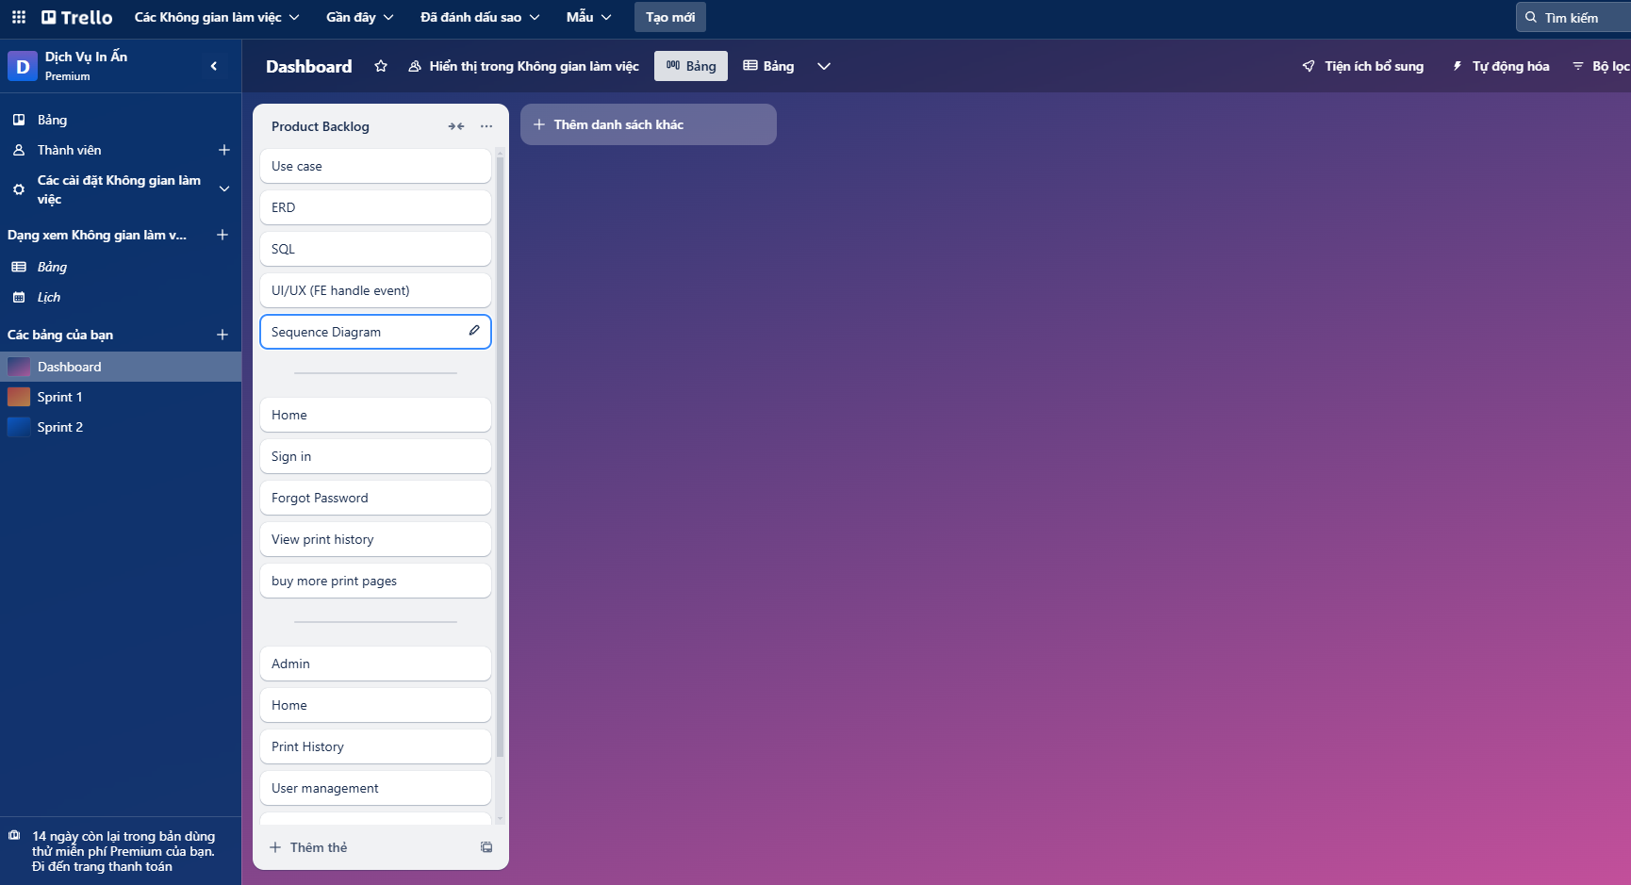

**Figure 3:**

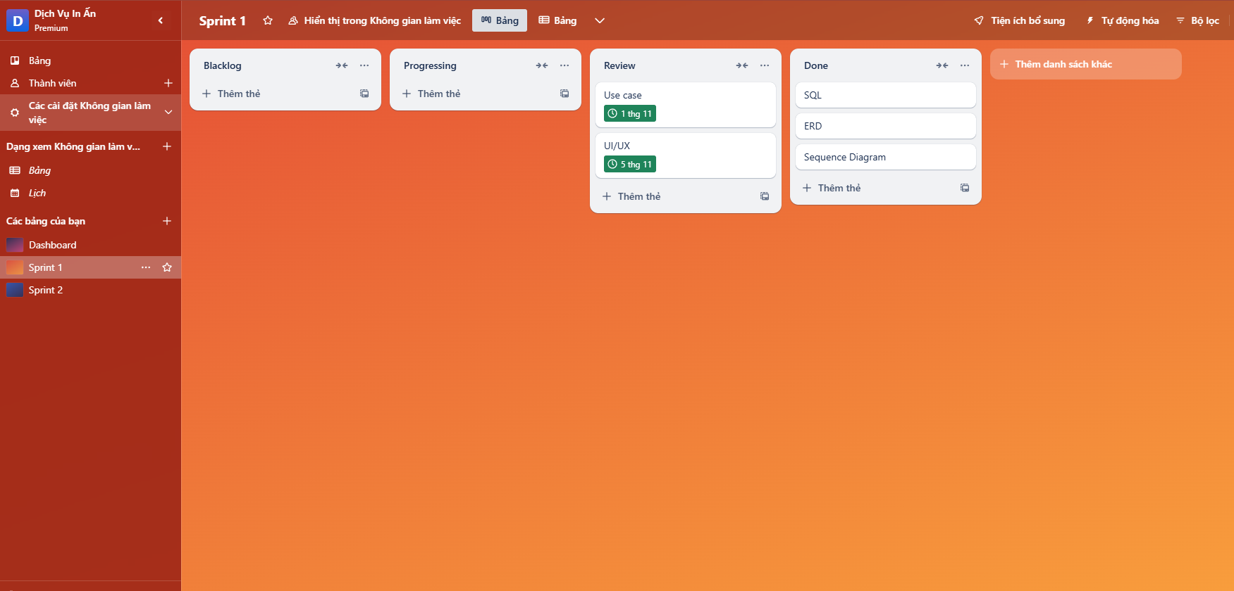

**Figure 4:**

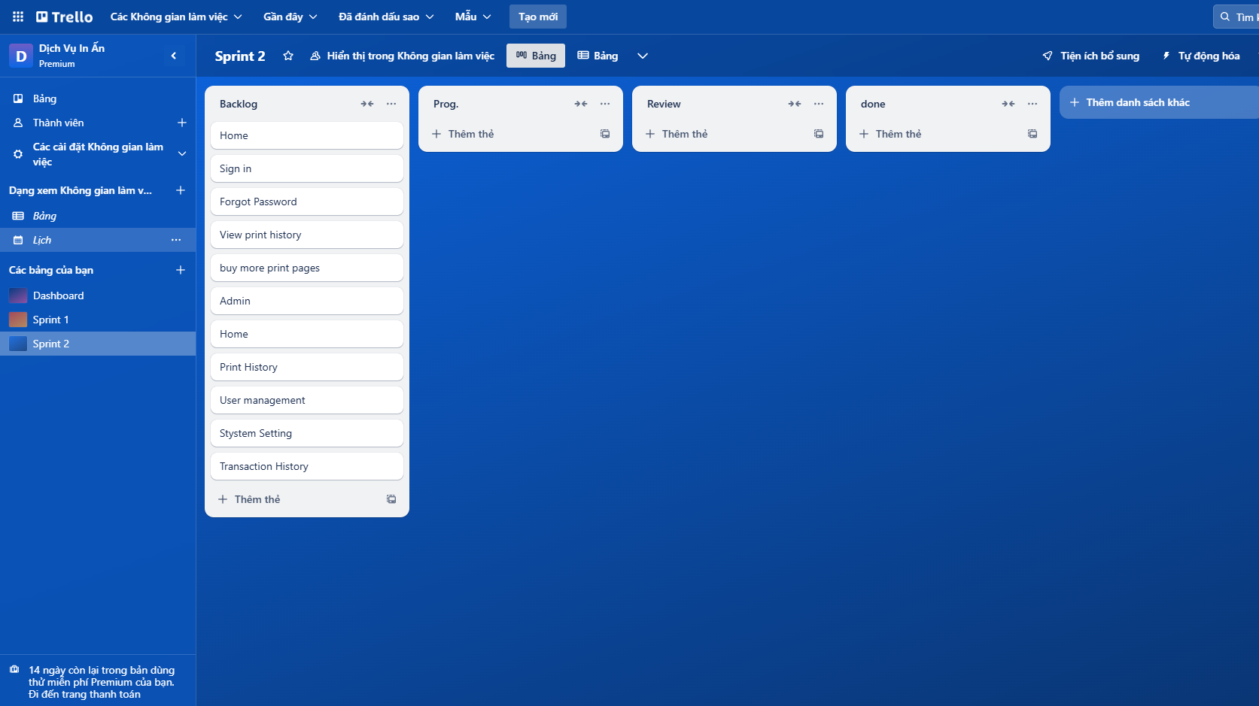

### 

### 7. General USE CASE Diagram

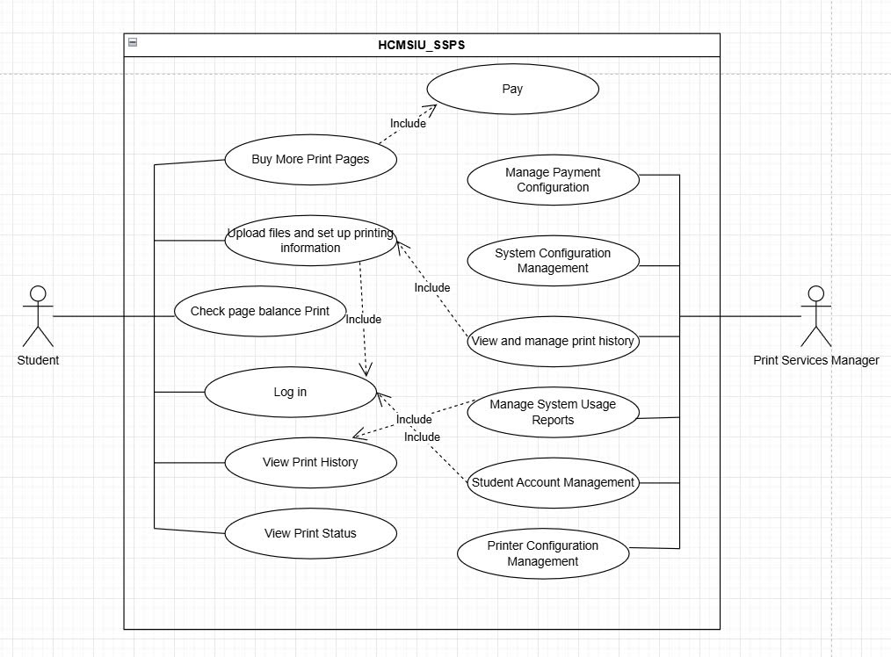

### 8. USE CASE Description

**Use Case 1: Login**

|  |  |
| --- | --- |
| **Use Case Name:** | Login |
| **Actors:** | Student |
| **Description:** | **This feature allows students to access the printing management system using their personal account credentials.** |
| **Preconditions:** | **- The student has been provided with a valid account including a username and password.**  **- The system is functioning properly.** |
| **Main Flow:** | Step 1: The system displays the login interface and prompts the student to provide:   * Username * Password   Step 2: The student enters their login credentials and clicks the Login button.  Step 3: The system verifies the credentials:   * If correct, a success message is displayed, and the system redirects to the main interface. * If incorrect, an error message is shown, and the student is prompted to retry. |
| **Alternate Flow:** | After three consecutive failed attempts, the system temporarily locks the account and displays a message instructing the student to contact the administrator. |
| **Postconditions:** | **-** If login is successful, the student can access the system's features.  - If login fails, the student returns to the login interface to try again. |
| **Special Notes:** | Passwords are encrypted to ensure security. |

**Use Case 2: Check Printing Balance**

|  |  |
| --- | --- |
| **Use Case Name:** | Check Printing Balance |
| **Actors:** | Student |
| **Description:** | This feature allows students to check the remaining number of printing pages in their account. |
| **Preconditions:** | The student has successfully logged into the system. |
| **Main Flow:** | - The student selects the Check Printing Balance option on the main interface.  - The system queries the database and displays the student's current printing balance. |
| **Alternate Flow:** | Connection or database query failure:   * The system displays an error message and prompts the student to try again later. |
| **Postconditions:** | The student knows their remaining printing balance. |
| **Special Notes:** | The printing balance is updated in real-time after each print or additional purchase. |

**Use Case 3: Purchase Additional Printing Pages**

|  |  |
| --- | --- |
| **Use Case Name:** | Purchase Additional Printing Pages |
| **Actors:** | Student |
| **Description:** | This feature allows students to add more printing pages to their account through payment**.** |
| **Preconditions:** | The student has logged into the system |
| **Main Flow:** | **Step 1:** The student selects the Purchase Additional Printing Pages option.  **Step 2:** The system displays an interface prompting the student to input the number of pages they wish to purchase.  **Step 3**: The student inputs the desired number of pages and clicks Continue**.**  **Step 4:** The system navigates to the payment interface:   * The student selects a payment method (e.g., e-wallet, credit/debit card, etc.). * The student provides payment details and confirms the transaction.   **Step 5: The system processes the payment:**   * If successful, the printing balance is updated, and a success message is displayed. * If unsuccessful, an error message is displayed, and the student is prompted to retry. |
| **Alternate Flow:** | The student's printing balance is updated after a successful transaction. |
| **Postconditions:** | The system records transaction details in the student's transaction history. |
| **Special Notes:** | **...** |

**Use Case 4: Upload File and Set Printing Details**

|  |  |
| --- | --- |
| **Use Case Name:** | Upload File and Set Printing Details |
| **Actors:** | Student |
| **Description:** | This feature allows students to upload documents for printing and configure detailed printing settings. |
| **Preconditions:** | The student has logged into the system. |
| **Main Flow:** | **Step 1:** The student selects the **Upload File and Set Printing Details** option.  **Step 2:** The system prompts the student to upload a document:   * The student selects a file from their device and uploads it. * The system validates the file format (e.g., PDF, DOCX).   **Step 3:** The system displays the printing settings interface, where the student configures:   * Number of copies * Paper type (A4, A3, etc.) * Black-and-white or color * Additional options if applicable.   **Step 4:** The student confirms the settings and clicks **Confirm Print**.  **Step 5:** The system saves the print request and queues the document for printing. |
| **Alternate Flow:** | The file is successfully uploaded, and the printing details are configured**.** |
| **Postconditions:** | The system automatically checks the printing balance before allowing confirmation. |
| **Special Notes:** | **...** |

**Use Case 5: View Printing History**

|  |  |
| --- | --- |
| **Use Case Name:** | View Printing History |
| **Actors:** | Student |
| **Description:** | This feature allows students to review the history of printed documents and related details. |
| **Preconditions:** | The student has successfully logged into the system. |
| **Main Flow:** | **Step 1:** The student selects the **View Printing History** option.  **Step 2:** The system queries the database and displays a history list, including:   * Document names * Number of printed pages * Printing timestamps * Printing balance before and after printing. |
| **Alternate Flow:** | The student can review their printing history for reference. |
| **Postconditions:** | **...** |
| **Special Notes:** | **...** |

**Use Case 6: Check Printing Status**

|  |  |
| --- | --- |
| **Use Case Name:** | Check Printing Status |
| **Actors:** | Student |
| **Description:** | This feature allows students to check the status of documents currently being printed or completed. |
| **Preconditions:** | The student has successfully logged into the system. |
| **Main Flow:** | **Step 1:** The student selects the **Check Printing Status** option.  **Step 2:** The system displays the current printing status, including:   * **Waiting:** The file is in the print queue. * **Printing:** The file is being printed. * **Completed:** The file has been printed successfully. |
| **Alternate Flow:** | The student is informed of the status of their documents. |
| **Postconditions:** | **...** |
| **Special Notes:** | **...** |

**Use Case 7:** Manage Payment Configuration

|  |  |
| --- | --- |
| **Use Case Name** | Manage Payment Configuration |
| **Description** | As a Print Services Manager, I want to manage the configuration of the payment functionality to ensure proper payment processing and setup. |
| **Actor(s)** | Print Services Manager |
| **Priority** | Must Have |
| **Trigger** | The Print Services Manager initiates the process to update or review payment configurations. |
| **Pre-Condition(s):** | * The Print Services Manager must be authenticated and authorized to access payment configuration settings. * The system must be operational and connected to the payment gateway. |
| **Post-Condition(s):** | * The updated payment configurations are saved successfully. * Any changes to payment configurations are validated and applied without affecting ongoing transactions. |
| **Basic Flow** | 1. The Print Services Manager navigates to the Payment Configuration section of the system. 2. The system displays the current payment configuration settings. 3. The Print Services Manager updates, adds, or removes payment options or configurations as needed. 4. The system validates the changes to ensure compliance with business rules. 5. Upon successful validation, the system saves the changes and provides a confirmation message. |
| **Alternative Flow** | 1. The Print Services Manager accesses the Payment Configuration section but does not make any changes.  2. The system allows the manager to review the current settings without saving any updates. |
| **Exception Flow** | If the payment gateway is unavailable during the configuration update, the system logs the issue and informs the manager to try again later. |
| **Business Rules** | BR1.1-1: All payment configurations must comply with the organization’s payment policies and supported formats. |
| **Non-Functional Requirement** | NFR1.1-1: The system must respond to configuration updates within 2 seconds. |

**Use Case 8:** System Configuration Management

|  |  |
| --- | --- |
| **Use Case Name** | System Configuration Management |
| **Description** | As a Print Services Manager, I want to manage the system configuration settings to ensure that the platform operates efficiently and aligns with organizational requirements |
| **Actor(s)** | Print Services Manager |
| **Priority** | Must Have |
| **Trigger** | The Print Services Manager initiates a request to update, review, or reset system configuration settings. |
| **Pre-Condition(s):** | * The Print Services Manager must be authenticated and have the necessary permissions to access system configurations. * The system must be online and accessible for configuration updates. |
| **Post-Condition(s):** | * The updated system configurations are saved and applied successfully. * All dependent modules and components operate with the updated settings without disruption. |
| **Basic Flow** | 1. The manager logs into the system with appropriate credentials. 2. The manager navigates to the System Configuration section. 3. The system displays the current configuration settings categorized by modules (e.g., performance, security, network). 4. The manager selects a configuration category and makes necessary updates or modifications. 5. The system validates the new configurations to ensure compliance with defined rules and dependencies. 6. Upon successful validation, the system saves the changes and confirms the update to the administrator. |
| **Alternative Flow** | * Alternative Flow 1 (View Only): 1.1 The manager accesses the System Configuration section in "Read-Only" mode. 1.2 The system displays all configurations without the ability to make changes. * Alternative Flow 2 (Reverting Changes): 2.1 The manager modifies a configuration but decides to revert to the previous state. 2.2 The system allows the manager to discard unsaved changes and restores the original settings. |
| **Exception Flow** | If the system encounters a failure during saving, it logs the error, notifies the administrator, and rolls back to the last valid configuration. |
| **Business Rules** | BR1.1-1: Any changes to security-related configurations must be logged for audit purposes. |
| **Non-Functional Requirement** | NFR1.1-1: All configuration data must be encrypted during storage and transmission |

**Use Case 9:** View and Manage Print History

|  |  |
| --- | --- |
| **Use Case Name** | View and Manage Print History |
| **Description** | As a Print Services Manager, I want to view and manage the print history to track, review, and maintain records of print jobs. |
| **Actor(s)** | Print Services Manager |
| **Priority** | Must Have |
| **Trigger** | The Print Services Manager initiates a request to access the print history. |
| **Pre-Condition(s):** | * The Print Services Manager must be authenticated and authorized to access print history. * The system must have stored print job records available for review. |
| **Post-Condition(s):** | * The requested print history is displayed to the manager. * Updates or deletions to specific records are saved, and the history is updated accordingly. |
| **Basic Flow** | 1. The Print Services Manager logs into the system and navigates to the Print History section. 2. The system displays a list of all print jobs with relevant details (e.g., job ID, user, document type, status, timestamp). 3. The manager searches for or filters specific print jobs using various criteria (e.g., date, user, or status). 4. The manager selects a specific print job to view detailed information. 5. The system displays detailed job information, including job settings, associated costs, and any errors or warnings. 6. The manager chooses an action (e.g., delete, archive, or update status) for one or more selected records. 7. The system validates the action and updates the print history accordingly. 8. A confirmation message is displayed to the manager. |
| **Alternative Flow** | 1 The manager selects multiple print records for archiving. 2 The system moves the selected records to an archive, removing them from the active view. |
| **Exception Flow** | If no print records match the search or filter criteria, the system displays a message indicating "No records found." |
| **Business Rules** | BR1.1-1: Print history must be retained for at least 12 months unless explicitly deleted by the manager. |
| **Non-Functional Requirement** | NFR1.1-1: The system must retrieve and display print history records within 3 seconds of the request. |

**Use Case 10:** Manage System Usage Reports

|  |  |
| --- | --- |
| **Use Case Name** | Manage System Usage Reports |
| **Description** | As a Print Services Manager, I want to generate, view, and manage system usage reports to monitor system performance and ensure efficient operations. |
| **Actor(s)** | Print Services Manager |
| **Priority** | Must Have |
| **Trigger** | The Print Services Manager requests to view or manage system usage reports. |
| **Pre-Condition(s):** | * The Print Services Manager must be authenticated and authorized to access usage reports. * The system must have logged sufficient usage data for reporting. |
| **Post-Condition(s):** | * The requested usage report is generated or displayed to the manager. * Any updates to reporting settings or scheduled reports are saved successfully. |
| **Basic Flow** | 1. The Print Services Manager logs into the system and navigates to the Usage Reports section. 2. The system displays available report types (e.g., performance, resource utilization, user activity). 3. The manager selects a report type and specifies parameters (e.g., date range, user group, or activity type). 4. The system processes the request and generates the report. 5. The manager views the report in the system, including visual representations like charts and graphs. |
| **Alternative Flow** | 1.The manager chooses to schedule a report for automatic generation at regular intervals. 2. The system saves the schedule and sends notifications when reports are ready. |
| **Exception Flow** | If no data is available for the selected parameters, the system displays a message indicating "No data available for the selected criteria." |
| **Business Rules** | BR1.1-1 Usage reports must comply with organizational data retention policies and privacy guidelines. |
| **Non-Functional Requirement** | NFR1.1-1: Exported reports must be encrypted to ensure data security during download. |

**Use Case 11:** Student Account Management

|  |  |
| --- | --- |
| **Use Case Name** | Student Account Management |
| **Description** | As a Print Services Manager, I want to manage student accounts to ensure proper registration, updating, and deactivation of student profiles for efficient system operation. |
| **Actor(s)** | Print Services Manager |
| **Priority** | Must Have |
| **Trigger** | The Print Services Manager initiates a request to manage student accounts (e.g., create, update, deactivate). |
| **Pre-Condition(s):** | * The Print Services Manager must be authenticated and authorized to manage student accounts. * The system must have a list of students registered in the system. |
| **Post-Condition(s):** | * The student account is created, updated, or deactivated as requested. * The student’s profile is reflected accurately in the system. |
| **Basic Flow** | 1. The Print Services Manager logs into the system and navigates to the Student Account Management section. 2. The system displays a list of all active student accounts. 3. The manager selects an action (e.g., create new account, view details, update account, deactivate account). 4. If creating a new account:  * The manager enters the required student details (e.g., name, ID, email, course). * The system validates the details and creates the account.  1. If updating an account:  * The manager selects the account to update and makes the necessary changes (e.g., email, address). * The system validates the changes and updates the account.  1. If deactivating an account:  * The manager selects the account to deactivate. * The system validates the action and deactivates the account. * The system displays a confirmation message for the action performed (e.g., account successfully created, updated, or deactivated). |
| **Alternative Flow** | 1. The administrator accesses the System Configuration section in "Read-Only" mode. 2. The system displays all configurations without the ability to make changes. |
| **Exception Flow** | If the system detects missing or invalid student information during account creation or update (e.g., incomplete data), it prompts the manager to correct the information. |
| **Business Rules** | BR1.1-1: New student accounts must include a unique student ID, valid email, and course enrollment details. |
| **Non-Functional Requirement** | NFR1.1-1: The system must process account creation, updates, and deactivation requests within 3 seconds. |

**Use Case 12:** Printer Configuration Management

|  |  |
| --- | --- |
| **Use Case Name** | Printer Configuration Management |
| **Description** | As a Print Services Manager, I want to manage the printer configurations to ensure printers are set up correctly and are functioning efficiently within the system. |
| **Actor(s)** | Print Services Manager |
| **Priority** | Must Have |
| **Trigger** | The Print Services Manager requests to view or manage the configuration settings of printers. |
| **Pre-Condition(s):** | * The Print Services Manager must be authenticated and authorized to manage printer configurations. * The system must have a list of printers registered and available for configuration. |
| **Post-Condition(s):** | * The requested printer configuration is updated, deleted, or restored as needed. * The system reflects the updated printer settings, and printers are configured accordingly. |
| **Basic Flow** | 1. The Print Services Manager logs into the system and navigates to the Printer Configuration Management section. 2. The system displays a list of all registered printers along with their current configuration settings. 3. The manager selects a printer from the list to view or edit its configuration. 4. The manager updates the necessary settings. 5. The system validates the changes and saves the updated configuration. 6. The system confirms the successful update of the printer configuration to the manager. |
| **Alternative Flow** | 1. The manager selects a printer to view its current configuration without making changes. 2. The system displays the printer’s settings in a read-only format. |
| **Exception Flow** | If the printer configuration update fails due to a system error or communication issue with the printer, the system logs the error and notifies the manager. |
| **Business Rules** | BR1.1-1: Only authorized Print Services Managers can modify printer configurations. |
| **Non-Functional Requirement** | NFR1.1-1: Printer configuration data must be securely stored and transmitted to prevent unauthorized access or tampering. |

### 9. Relationship diagram

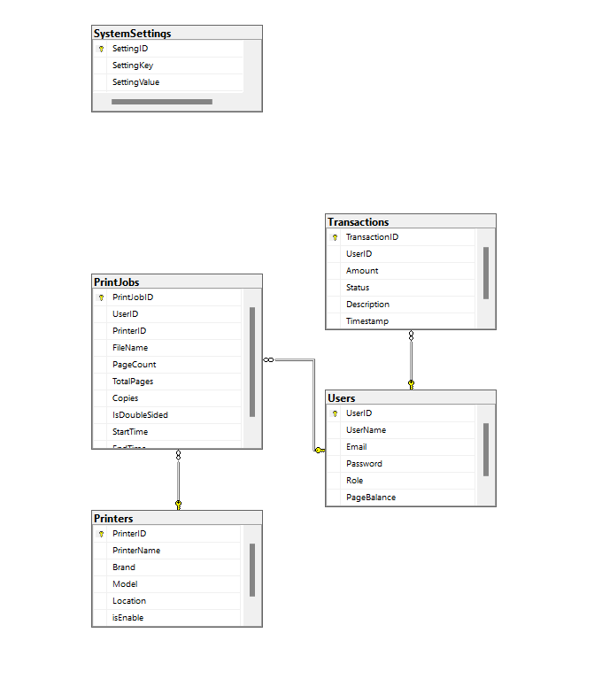

**10. Activity Diagram**

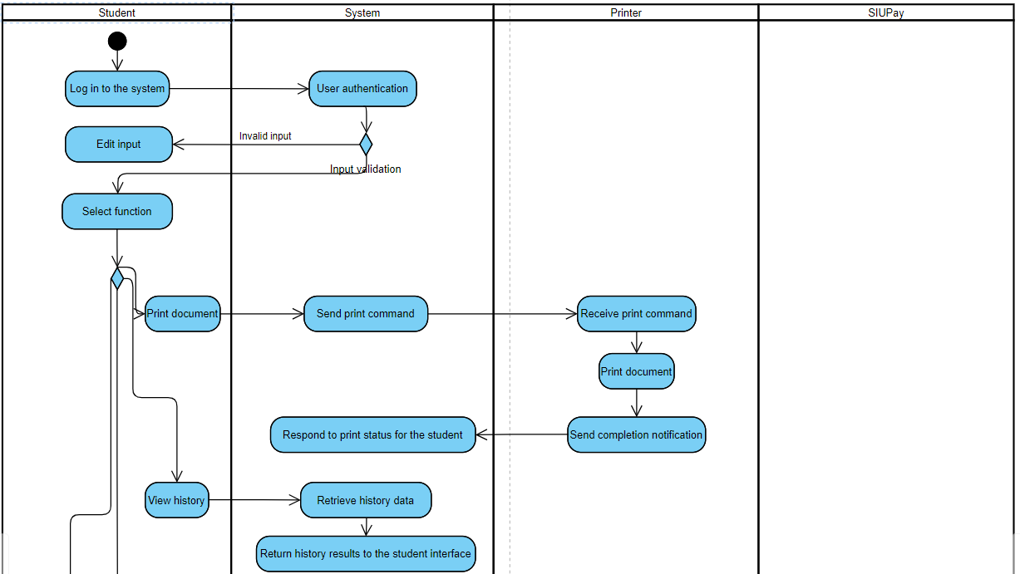

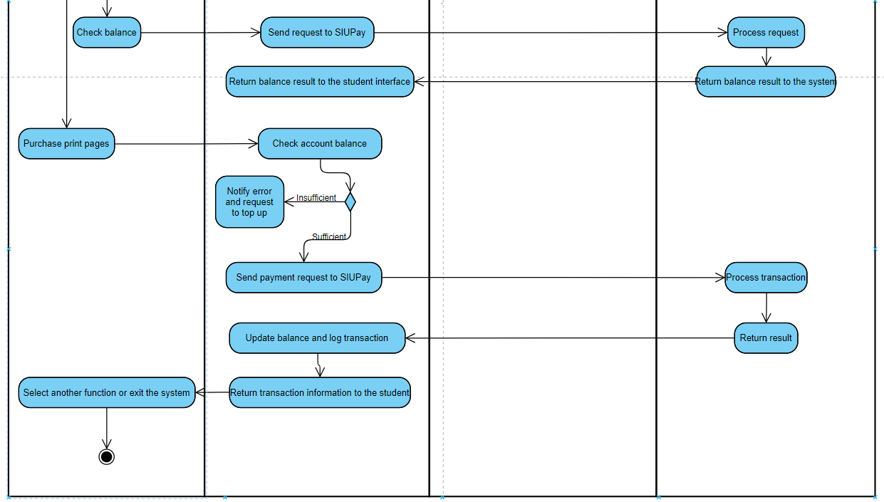

**Activity Diagram Description**:  
The Activity Diagram describes the process of how students use the printing system, covering the functions of **Print Document**, **View History**, **Purchase Print Pages**, and **Check Balance**. After logging in and being authenticated by the system, the student selects the function they want to perform. The system processes the request, connects with components such as the **Printer**, **SIUPay**, or the **Database**, and responds with the result back to the student interface. The process ensures ease of operation and transparency of information.

### 11. Sequence Diagram

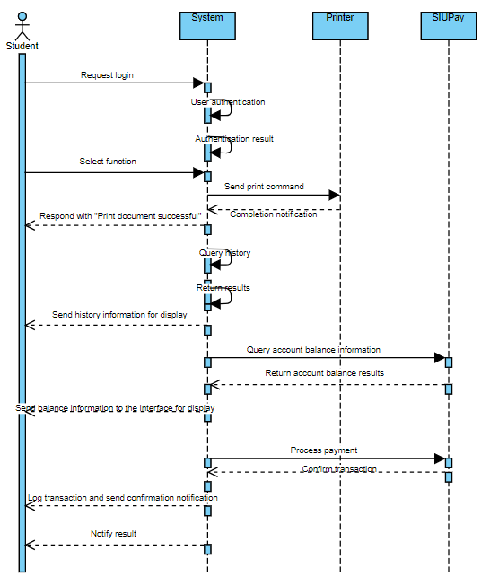

**Sequence Diagram Description:**The Sequence Diagram illustrates the detailed interactions between the Student, System, Printer, SIUPay, and Database in the printing system. The process starts when the Student logs in and selects a function, including Print Document, View History, Purchase Print Pages, and Check Balance. The System plays a central role in processing requests, validating input data, performing transactions, and responding with results. The Printer receives the print command from the System, SIUPay processes the payment, and the Database provides history or balance data. Each function ensures that feedback is returned to the Student, allowing the user to clearly understand the operation status or related information in an accurate and timely manner**.**

### 12. Class Diagram

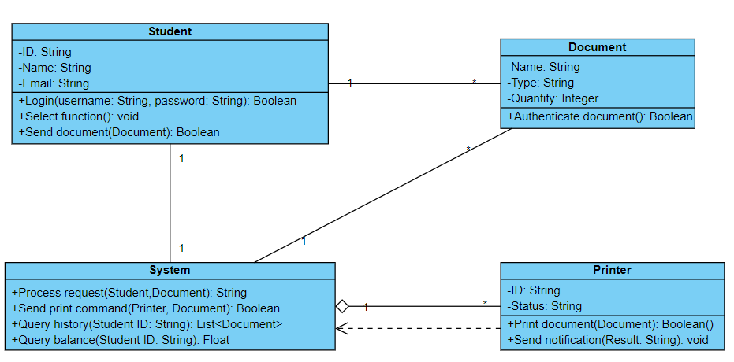

### 13. Layered Architecture

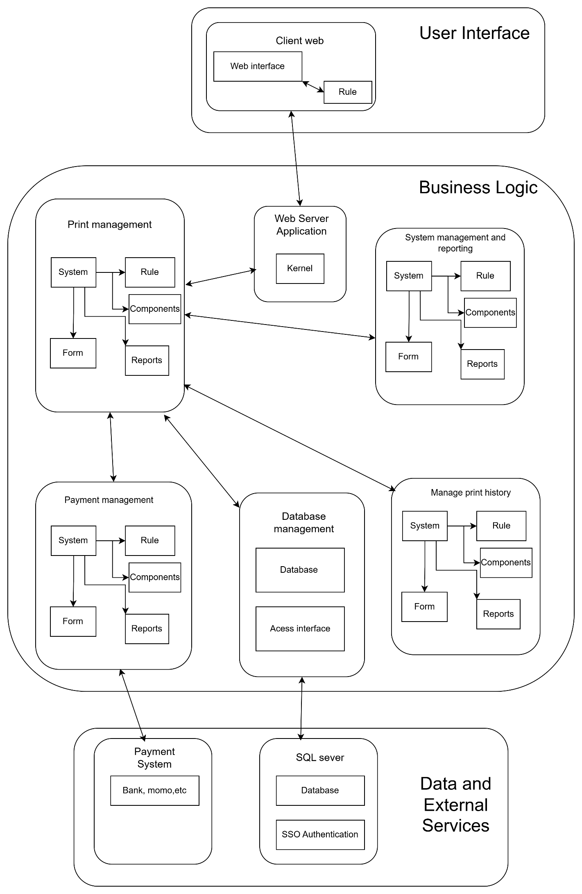

Our project adopts the Model-View-Controller (MVC) architectural pattern, ensuring a clear separation of concerns between the user interface, business logic, and data management. The View layer is built using HTML and CSS, offering a responsive and user-friendly interface that is independent of the underlying logic. The Controller layer, developed in C#, acts as the intermediary between the user and the system, processing user inputs and interacting with the Model layer. The Model layer handles core business logic and data processing, dynamically fetching real-time data from external APIs or services instead of storing it locally, thus improving performance and scalability. This architecture promotes maintainability, modularity, and scalability by decoupling each part of the system, allowing easier updates and expansion in the future.

The project relies on external APIs and client-side storage (localStorage, sessionStorage) to manage data during user sessions, with SQL databases used for storing non-sensitive data. Sensitive information is processed in memory during transactions and discarded afterward to comply with privacy standards. Data fetched from APIs is dynamically integrated into the application for a smooth user experience, and secure data handling practices follow industry guidelines, including the OWASP Secure Storage Guidelines, to protect sensitive information.

The project incorporates optional payment API integration, which may include services like banking APIs or MoMo for payment processing. These APIs are accessed through secure RESTful protocols, ensuring encrypted communication over HTTPS. By integrating the API with the MVC framework, payment transactions are handled efficiently without storing any sensitive data on the server. This design ensures compliance with industry standards for financial data security.

### 14. UI/UX

14.1. Login screen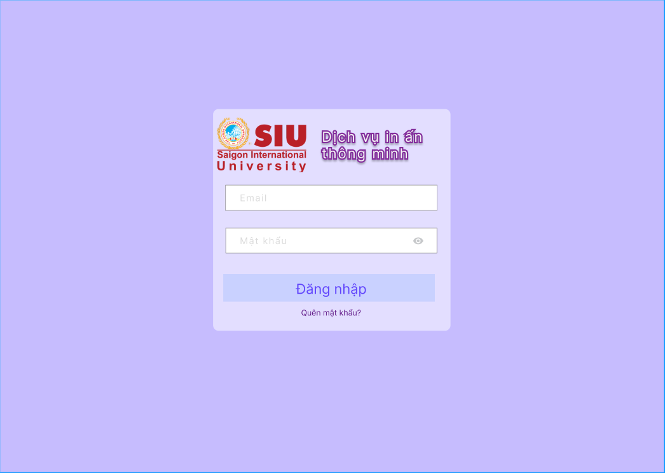

14.2 Forgot password screen 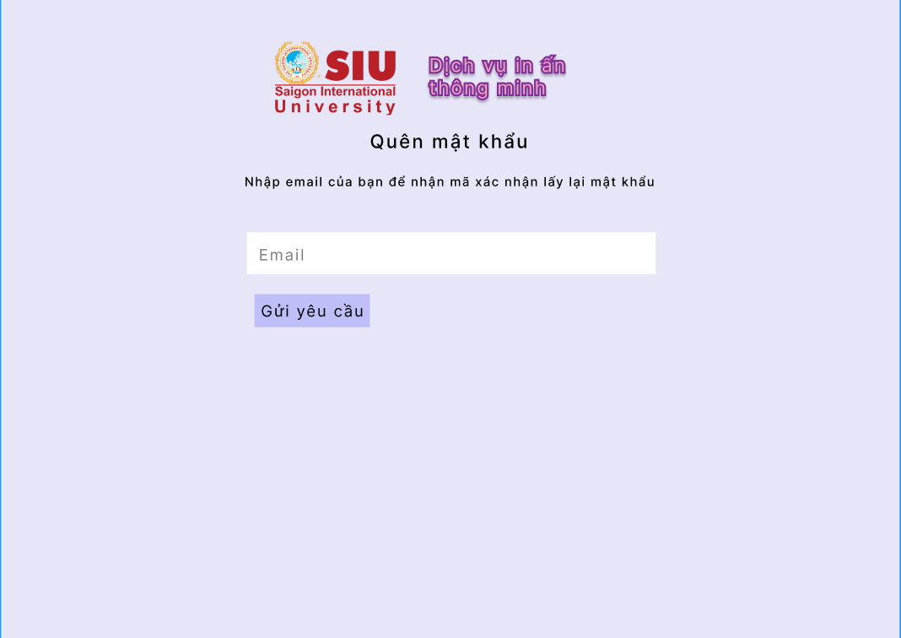

14.3. Home screen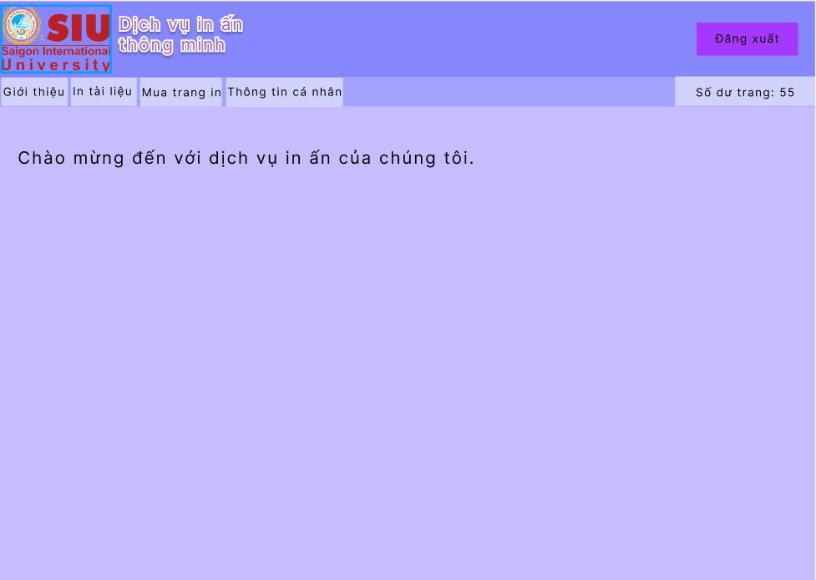

14.4. Introduction screen

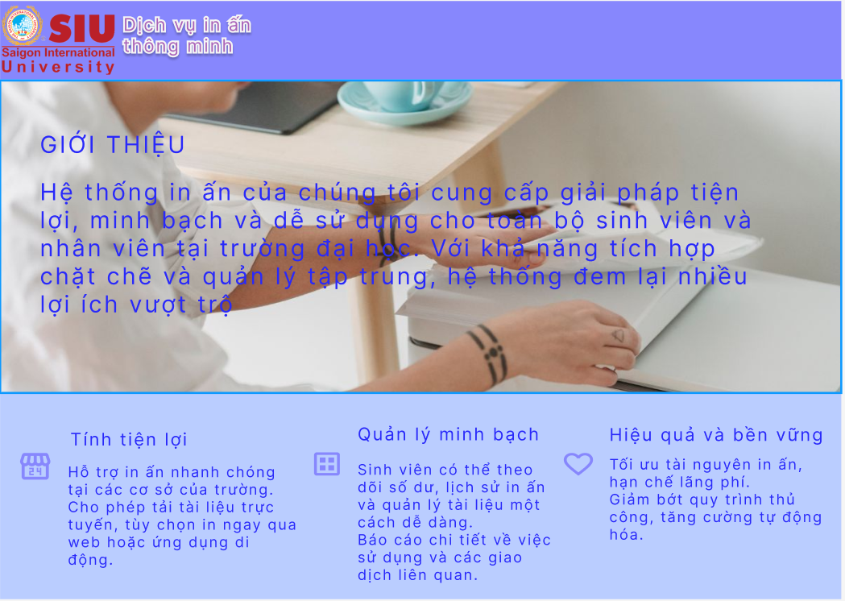

14.5. Print document screen

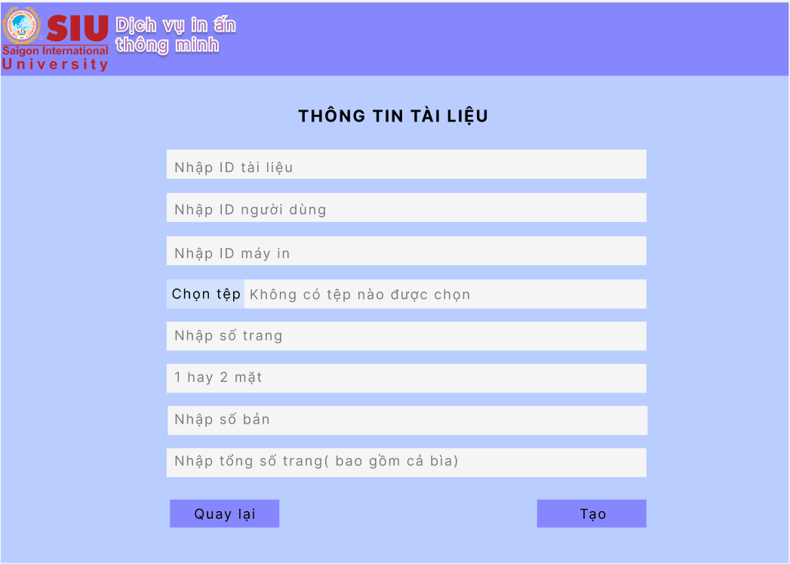

14.6. Purchase additional print pages screen

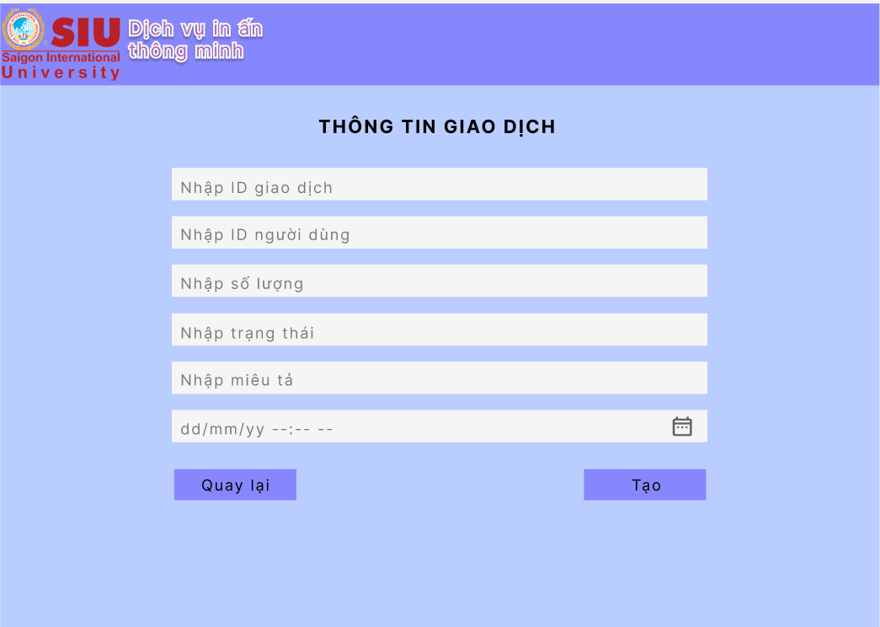

14.7. Payment screen

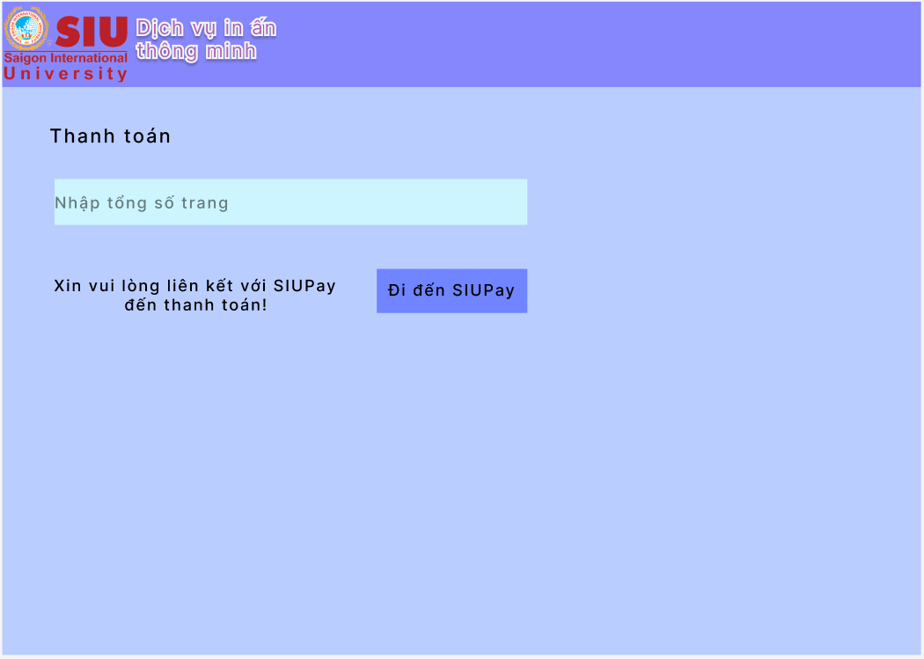

14.8. Account management screen

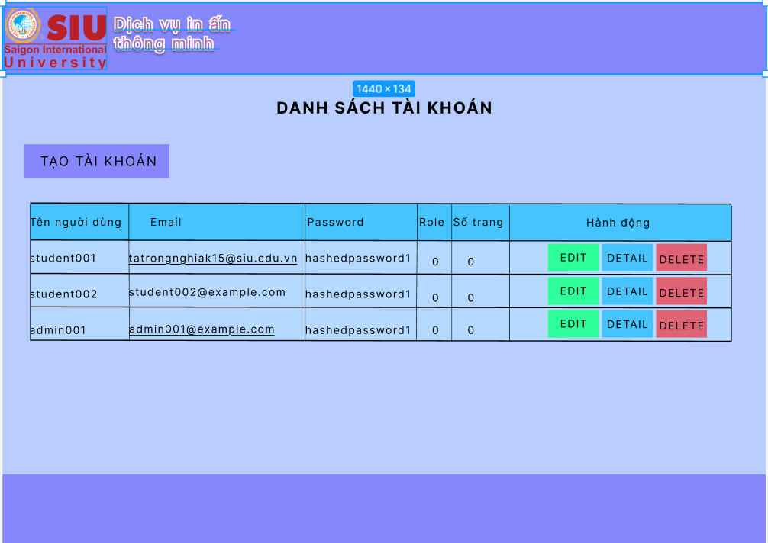

14.9. System configuration management screen

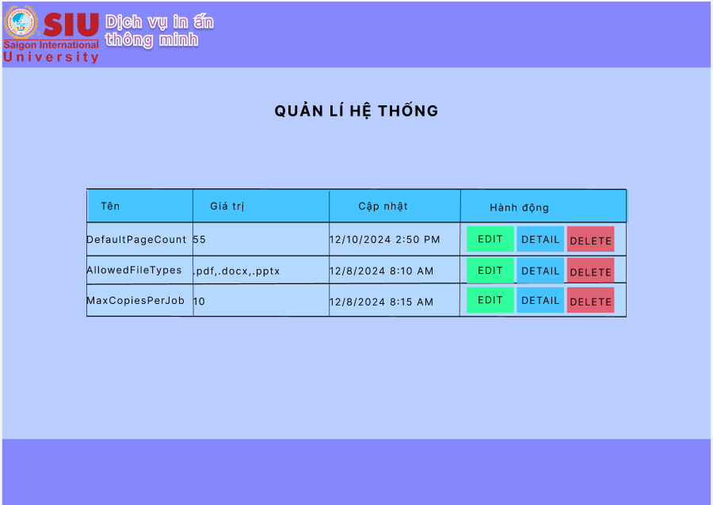

14.10. Print history management screen

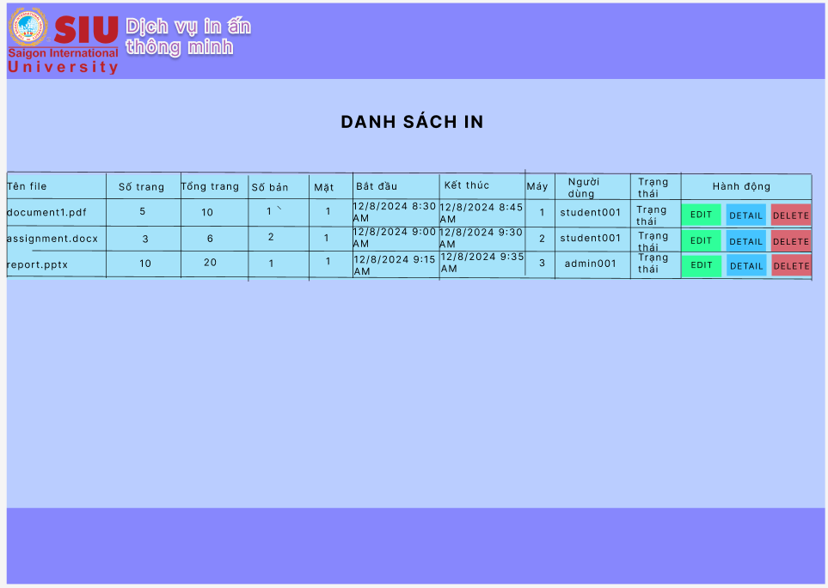

## CHAPTER 3: WEBSITE DEVELOPMENT

### 1. Request

CPU: Quad-core CPU with a speed of 2 GHz or higher.

RAM: 4 GB RAM or higher.

Storage: 20 GB storage or higher.

Domain Name: A domain name that is memorable and relevant to your brand.

Web Hosting: A reputable web hosting service that can provide enough storage and bandwidth for your website.

Design: A website design that is attractive and easy to use.

### 2. Software interface

**2.1. Website Introduction**

Medical examination registration management software is an integrated system designed to optimize the registration process and manage examination schedules at medical facilities. The system supports everything from appointment scheduling, patient information management, to tracking medical examination history, bringing convenience to both medical facilities and patients.

With a friendly and easy-to-use interface, the software not only helps reduce administrative work for medical staff but also creates conditions for patients to easily access and use the service.

**2.2. User interface**

*2.2.1. Login page interface*

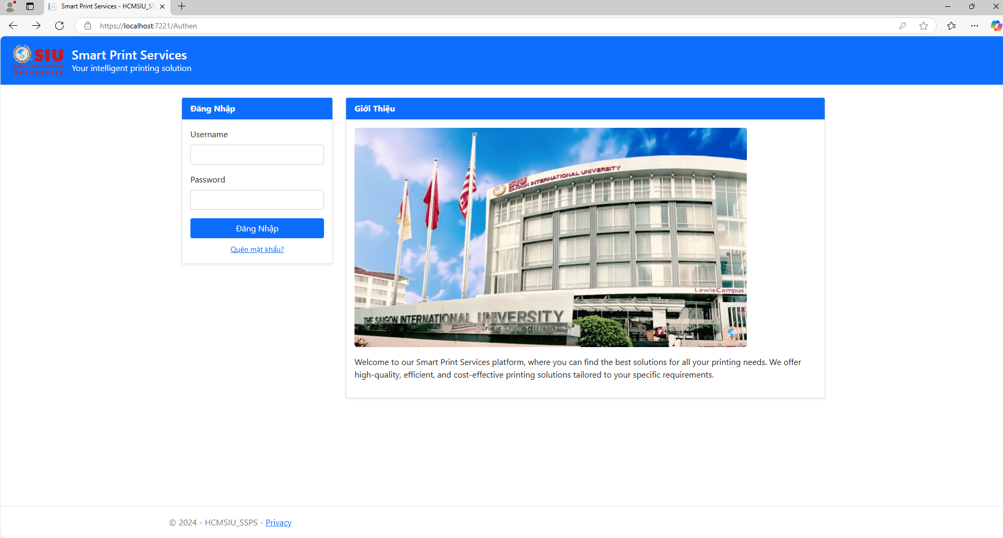

*2.2.2. Forgot Password Interface*

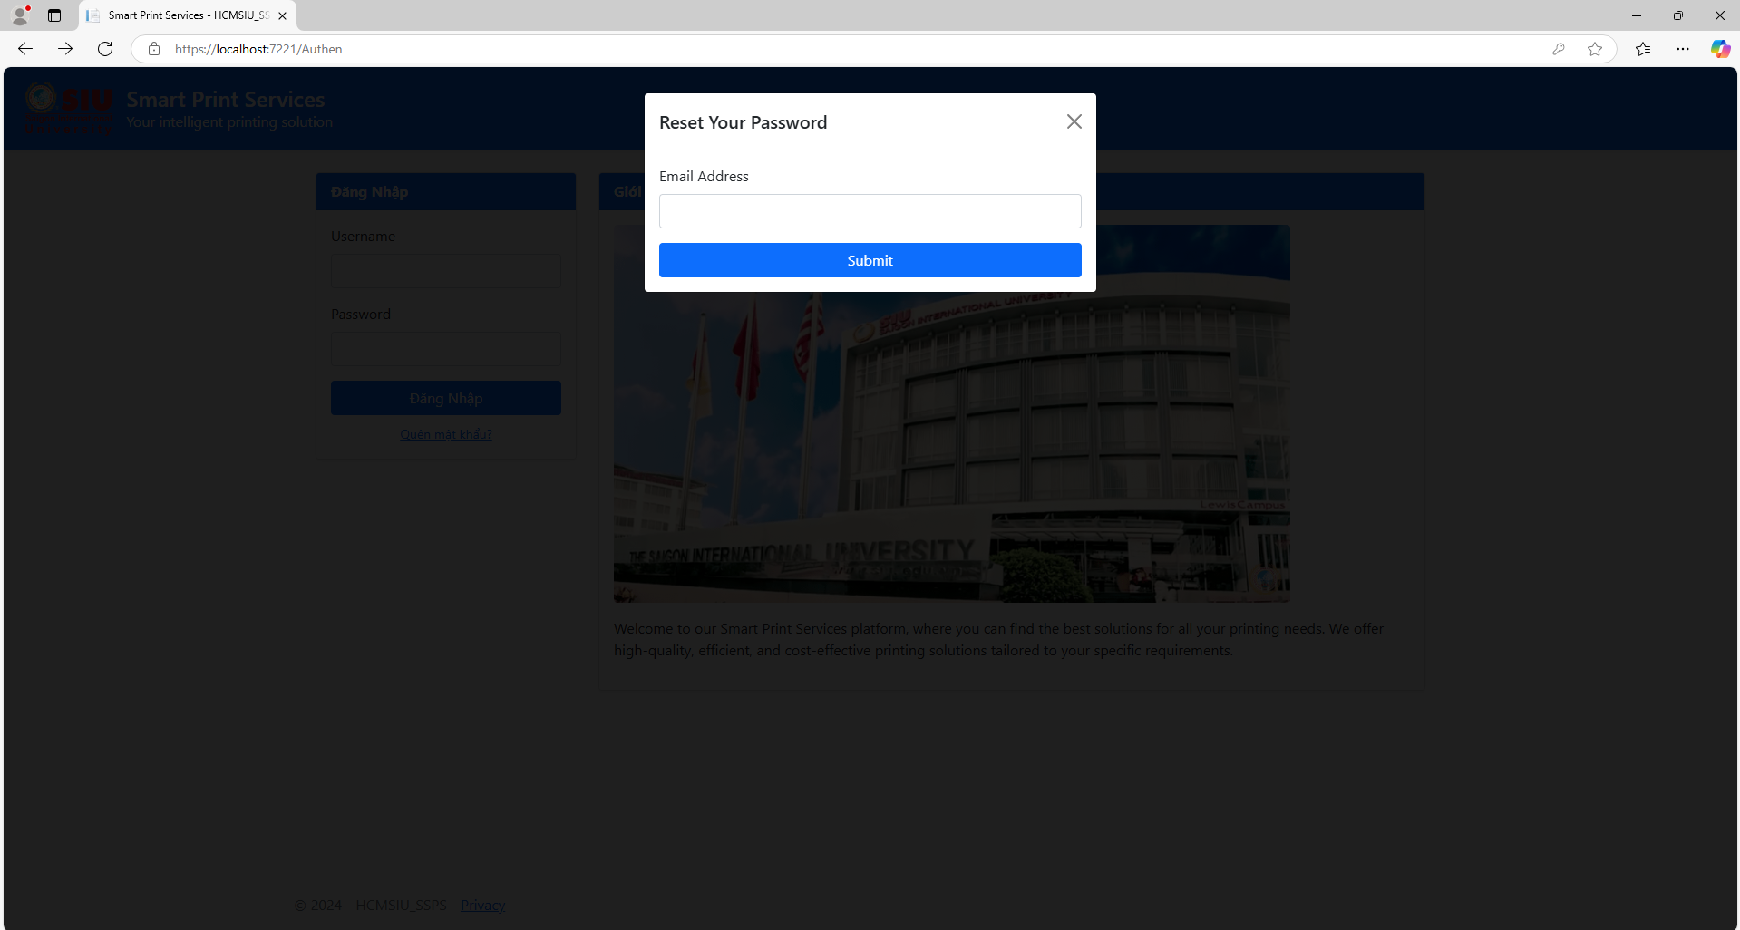

*2.2.3. Home page interface*

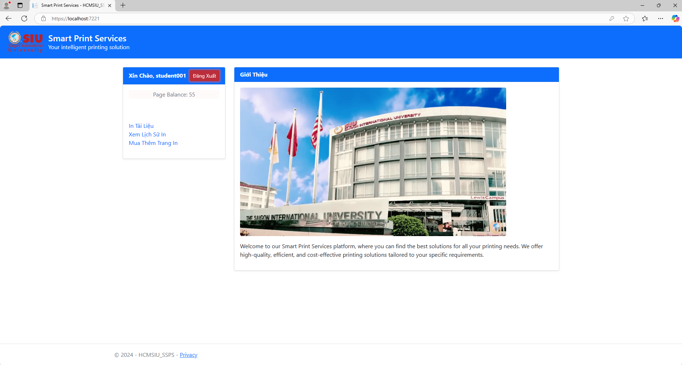

*2.2.4. Document printing interface*

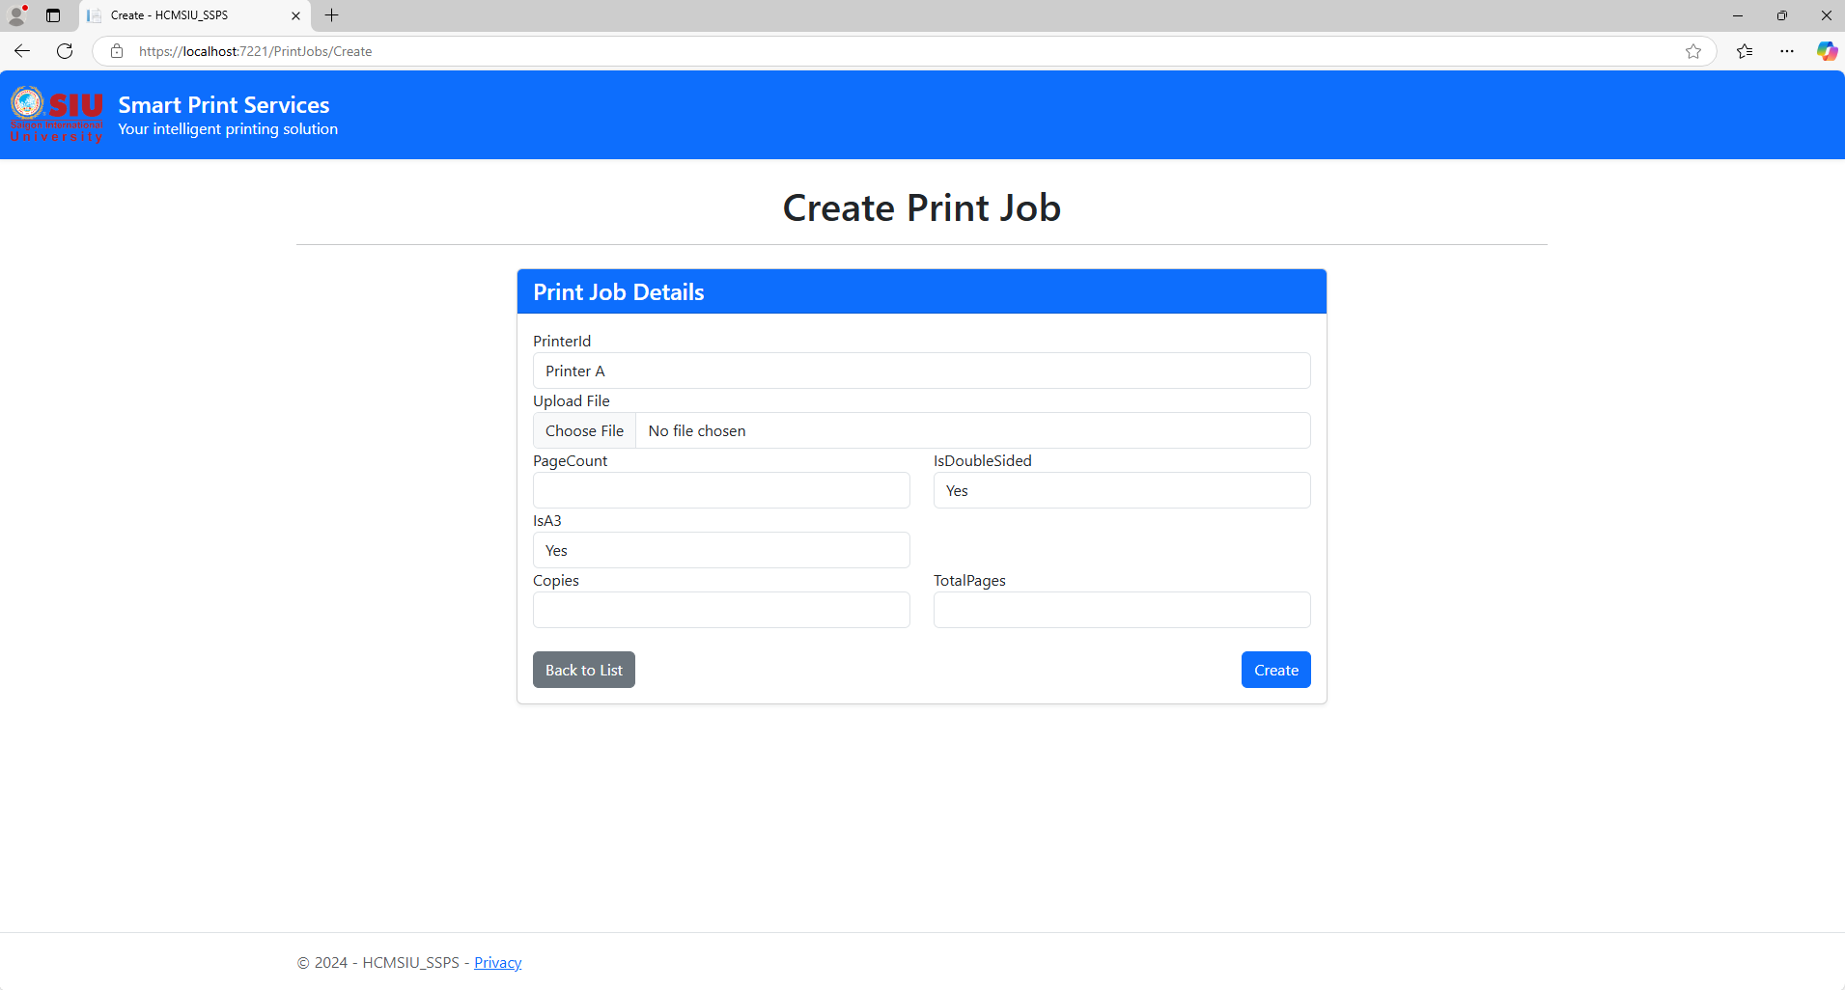

*2.2.5. Interface to buy additional print pages*

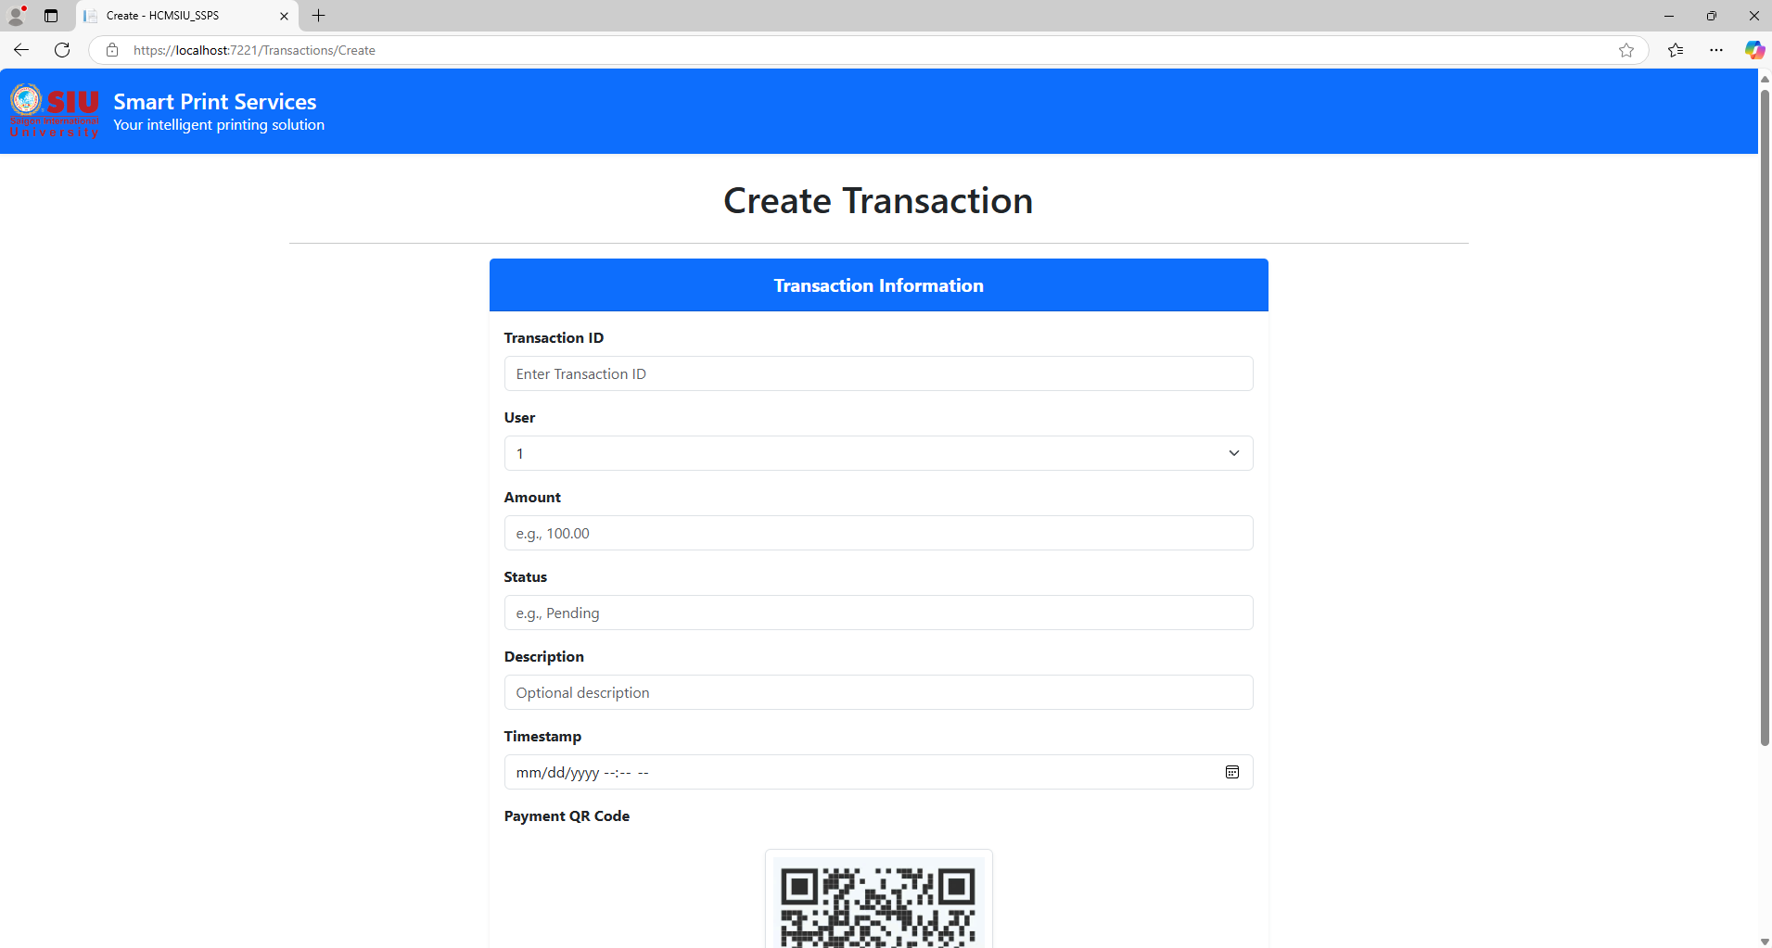

*2.2.6. Payment interface*

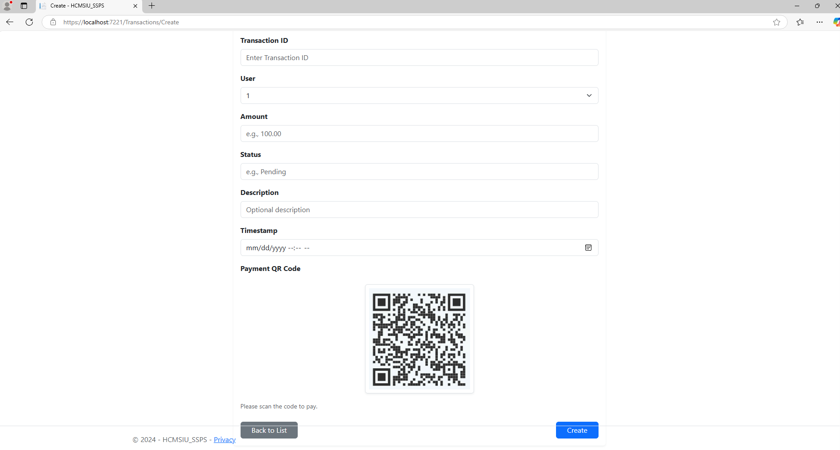

*2.2.7. Admin homepage interface*

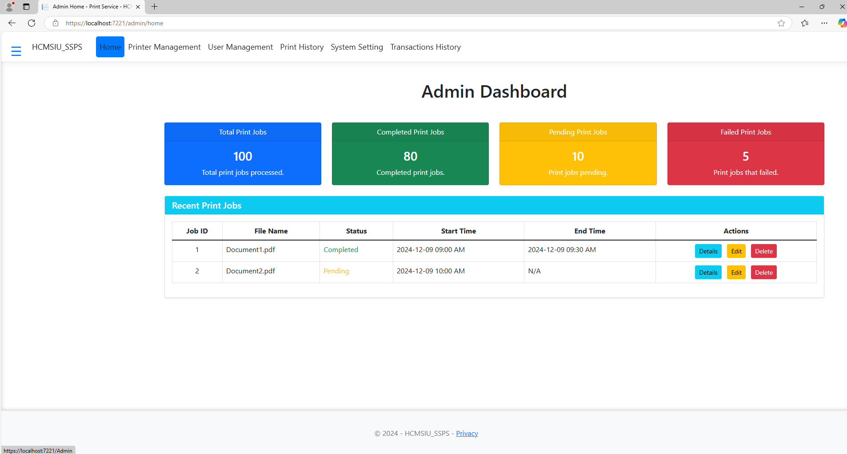

*2.2.8. Printer management interface*

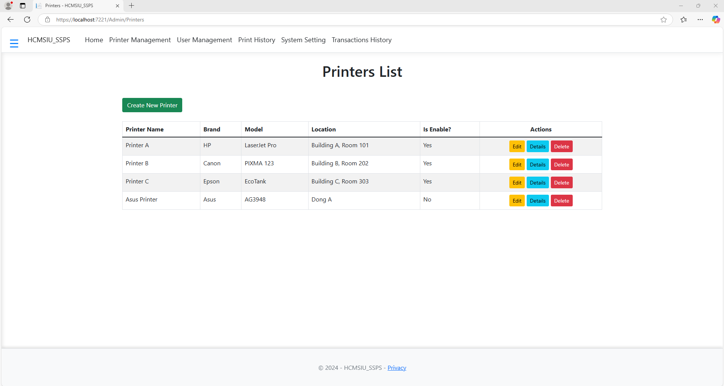

*2.2.9. Add printer interface*

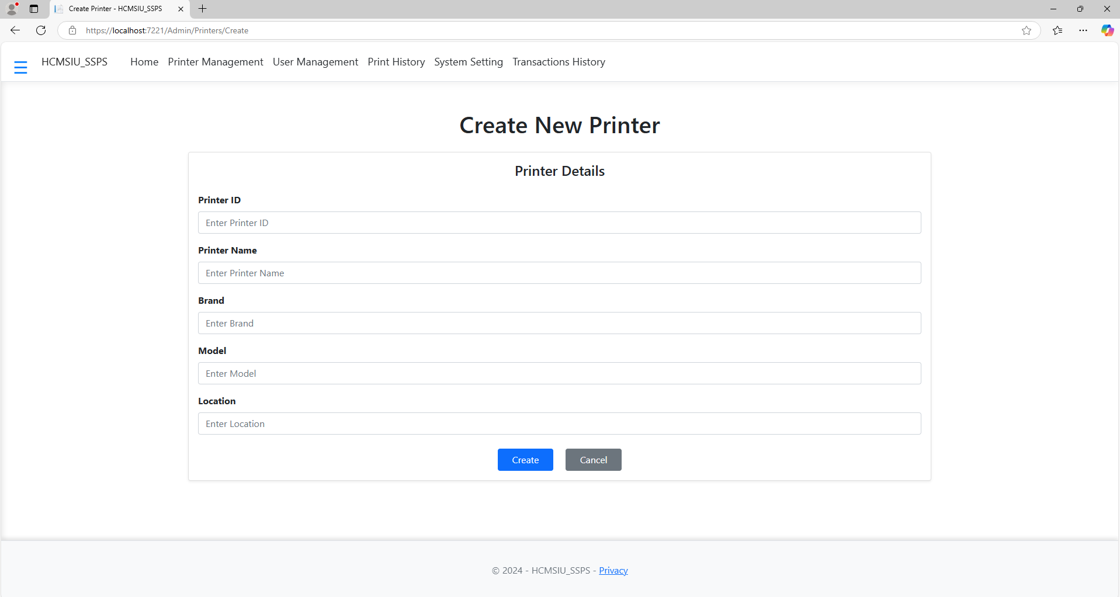

*2.2.10. Printer editing interface*

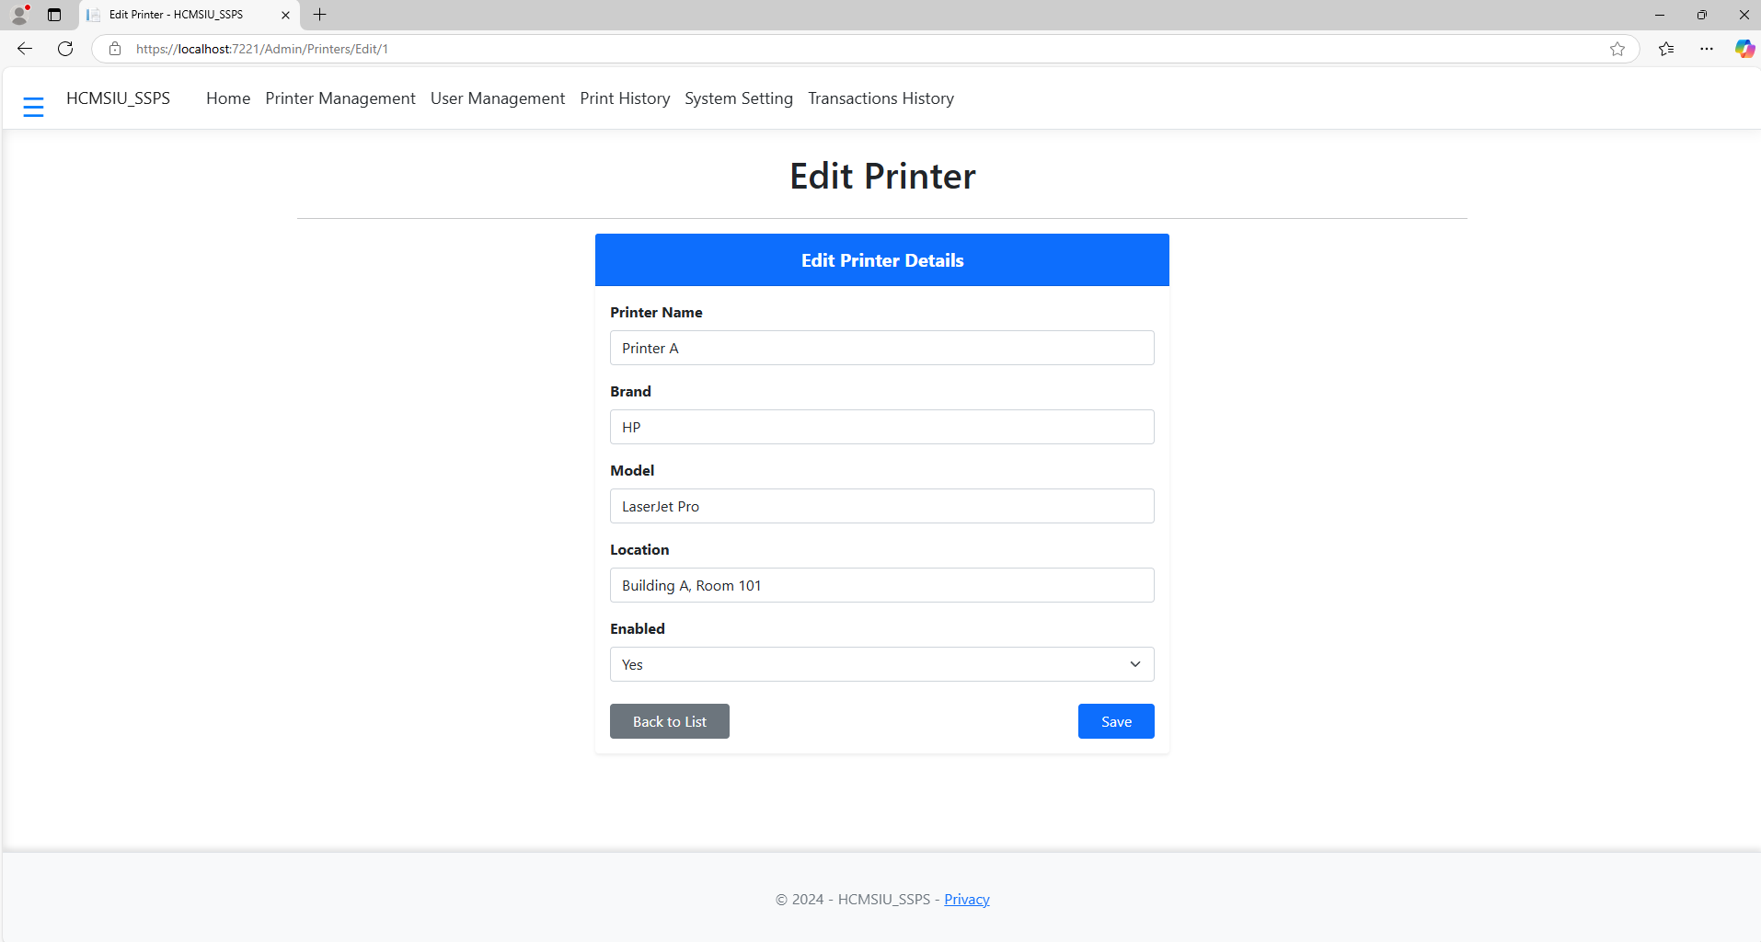

*2.2.11. Printer detail interface*

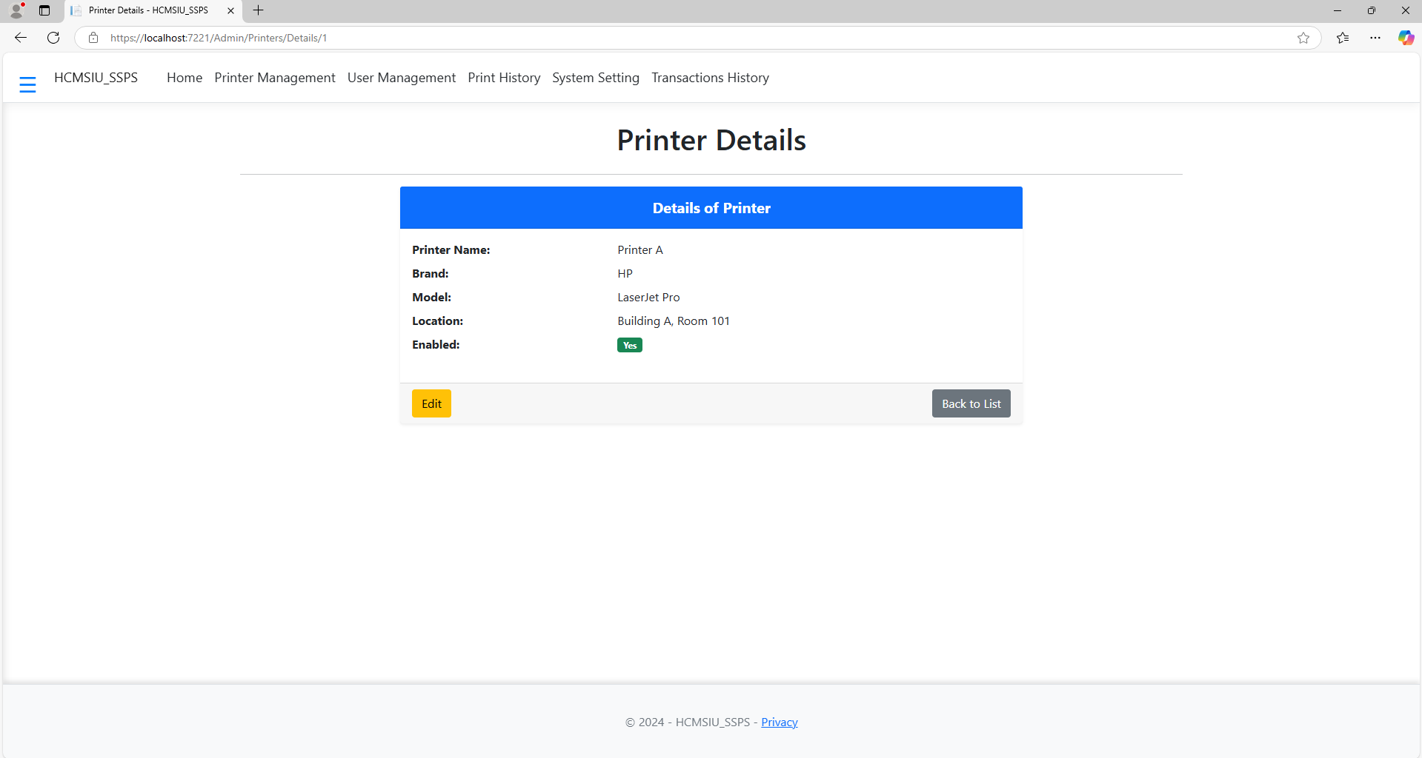

*2.2.12. Printer delete interface*

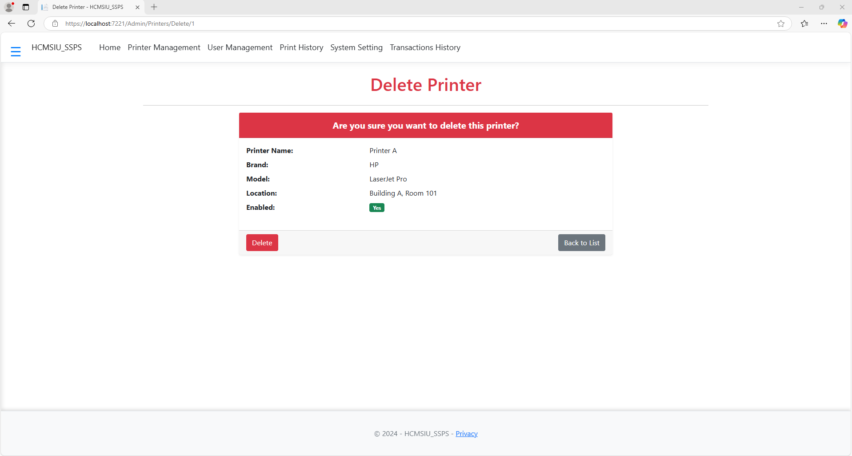

*2.2.13. Account management interface*

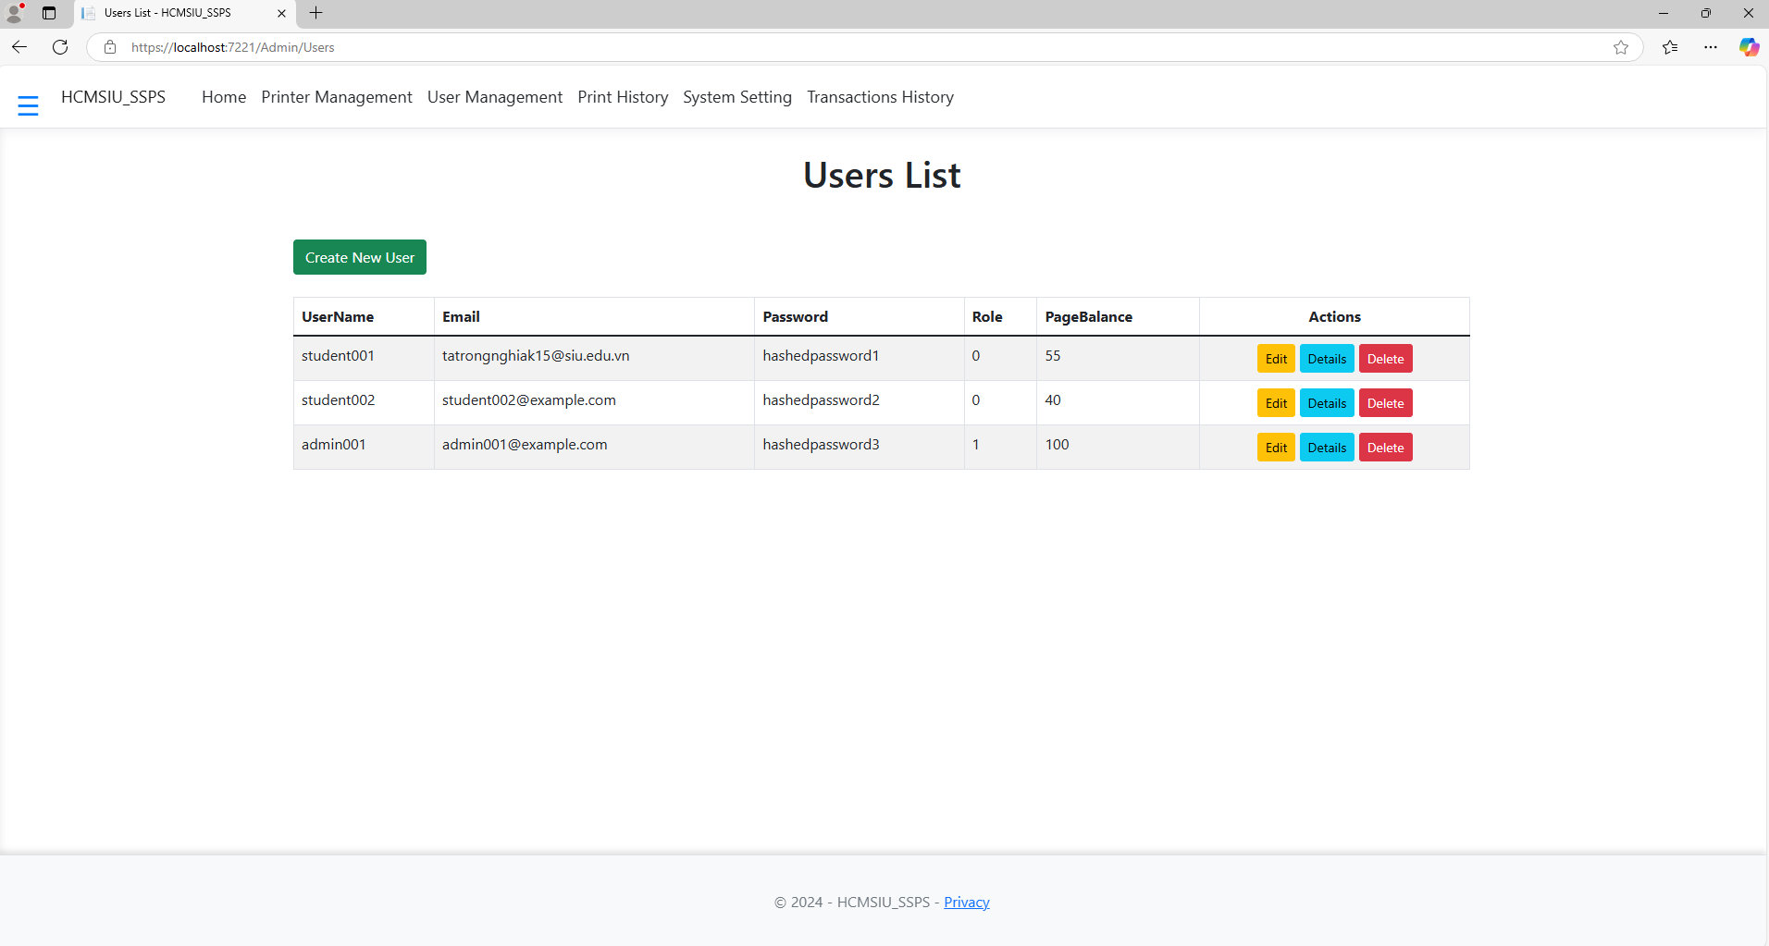

*2.2.14. New account add interface*

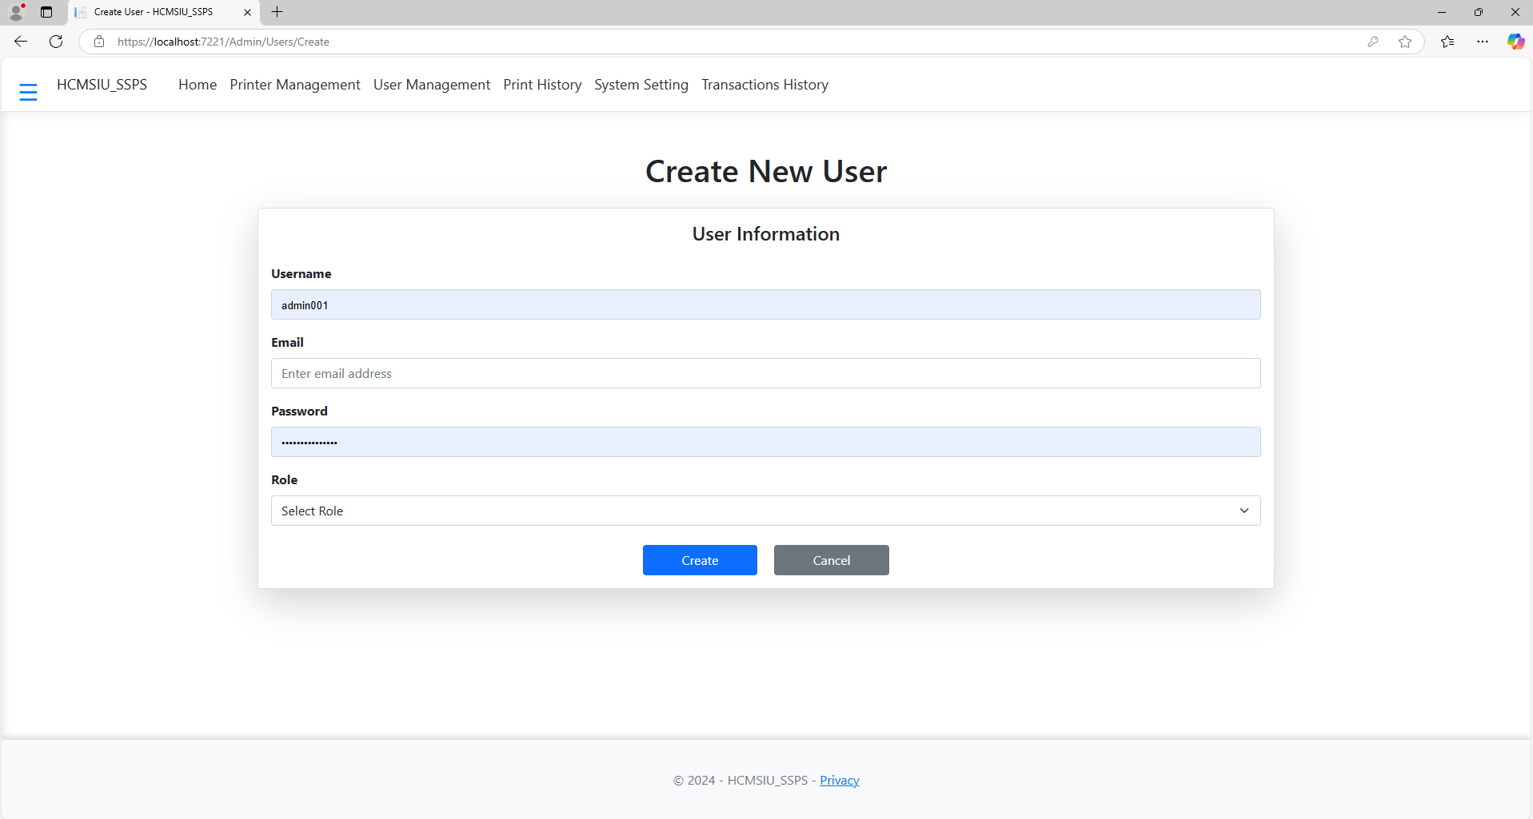

*2.2.15. Account editing interface*

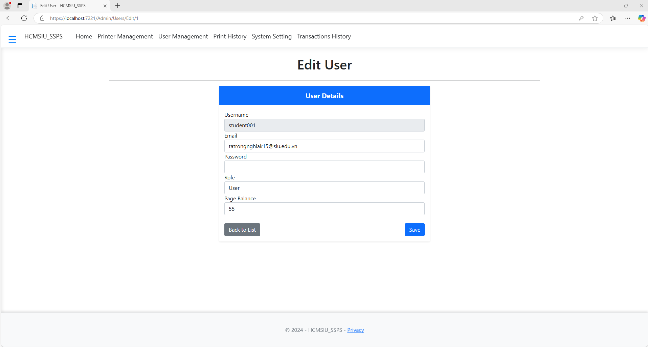

*2.2.16. Account details interface*

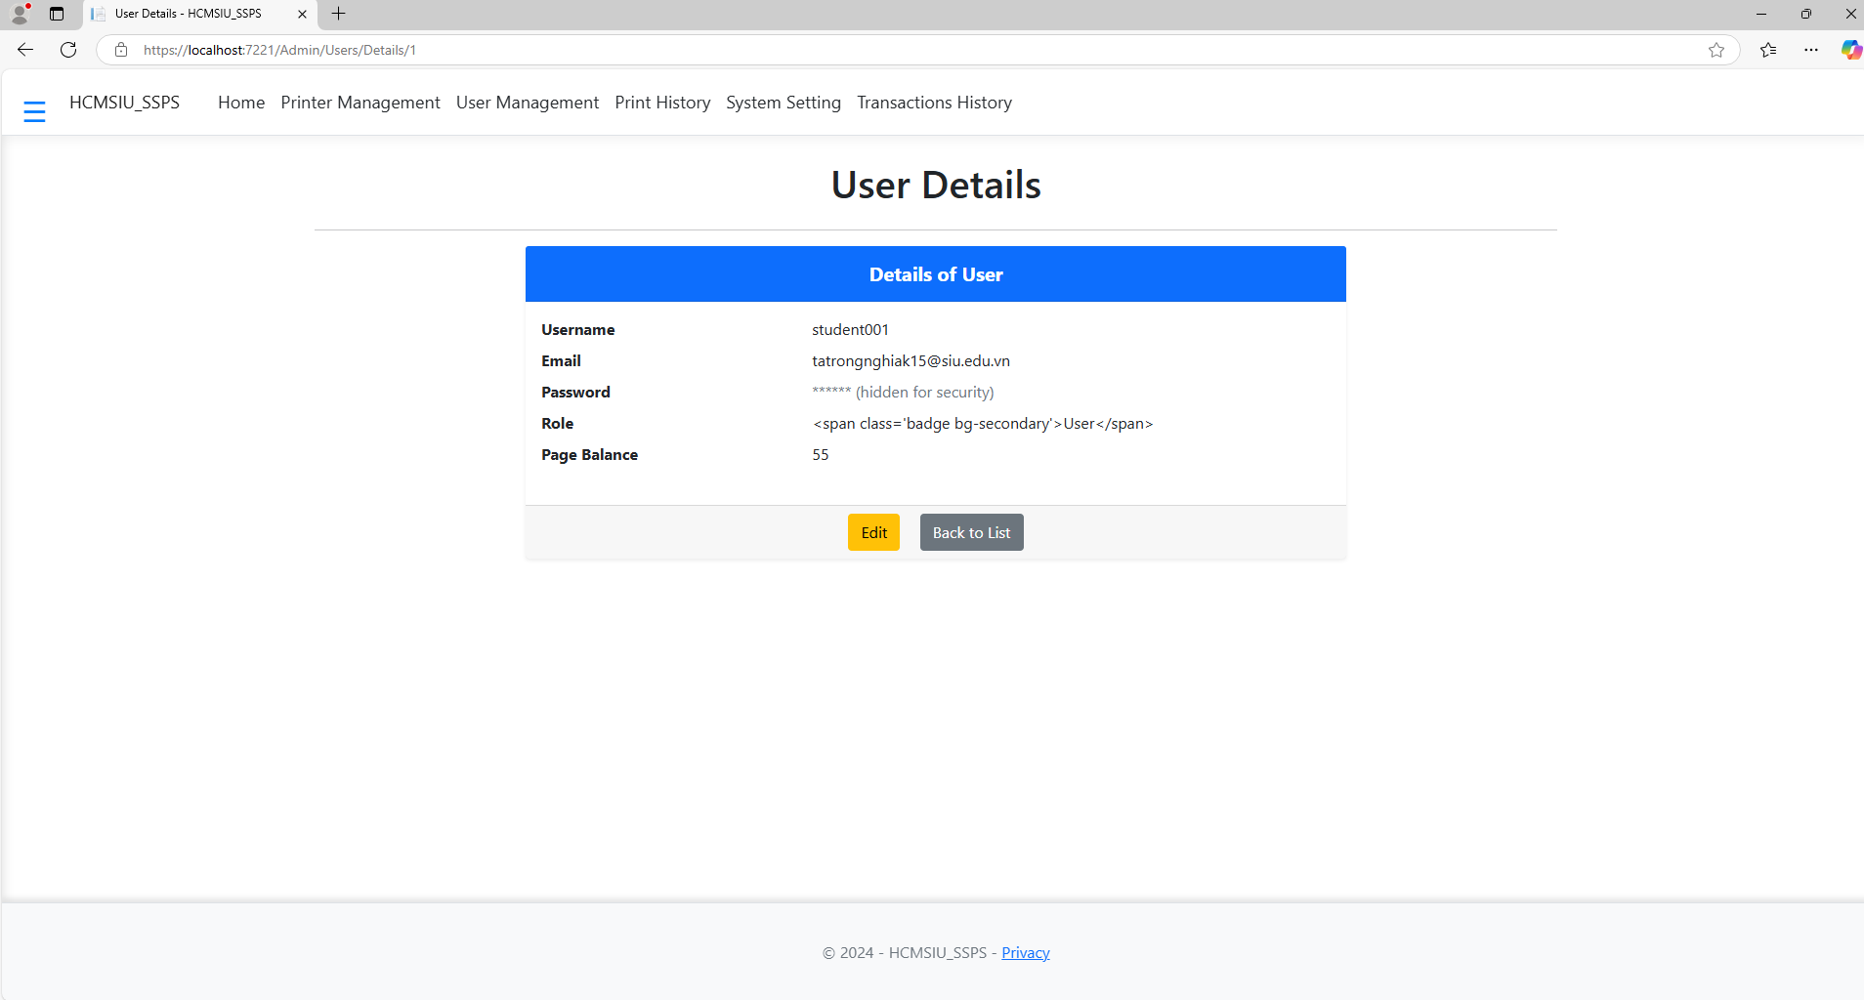

*2.2.17. Account deletion interface*

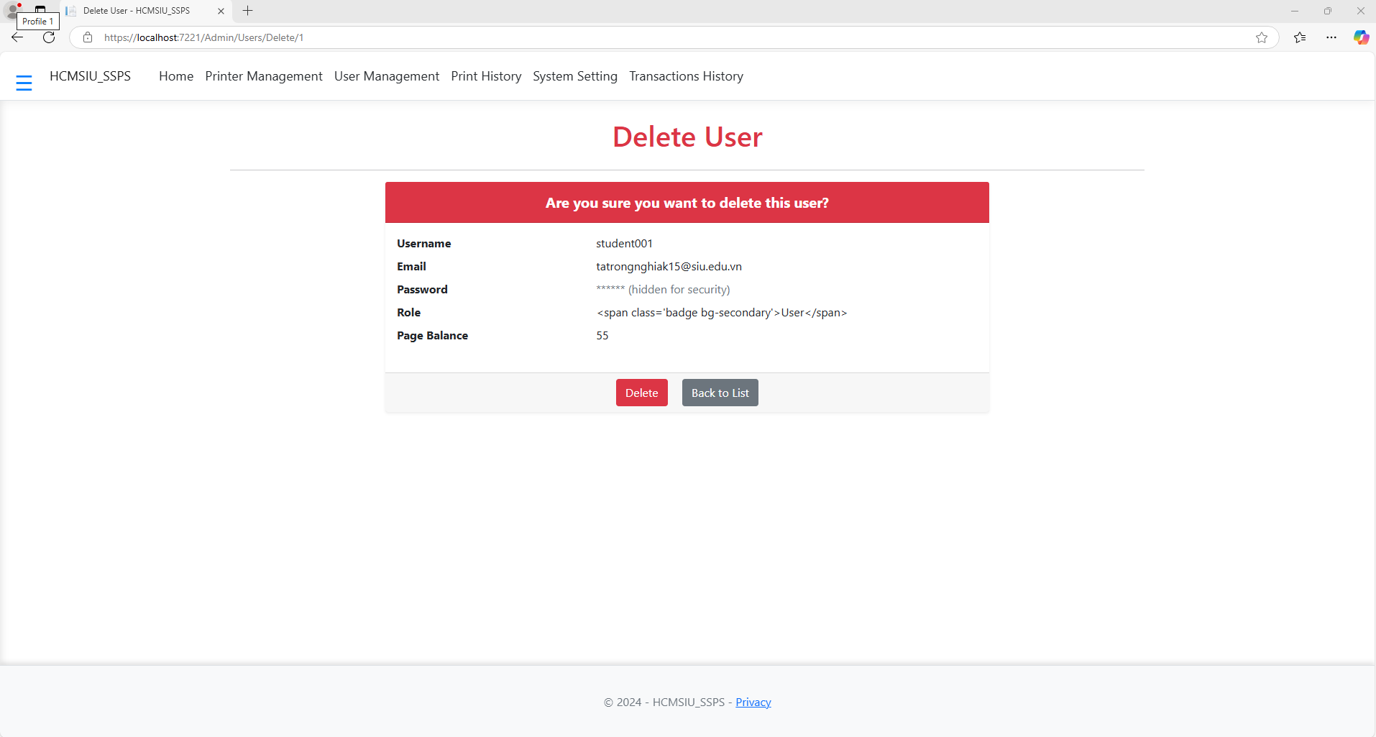

*2.2.18. System configuration management interface*

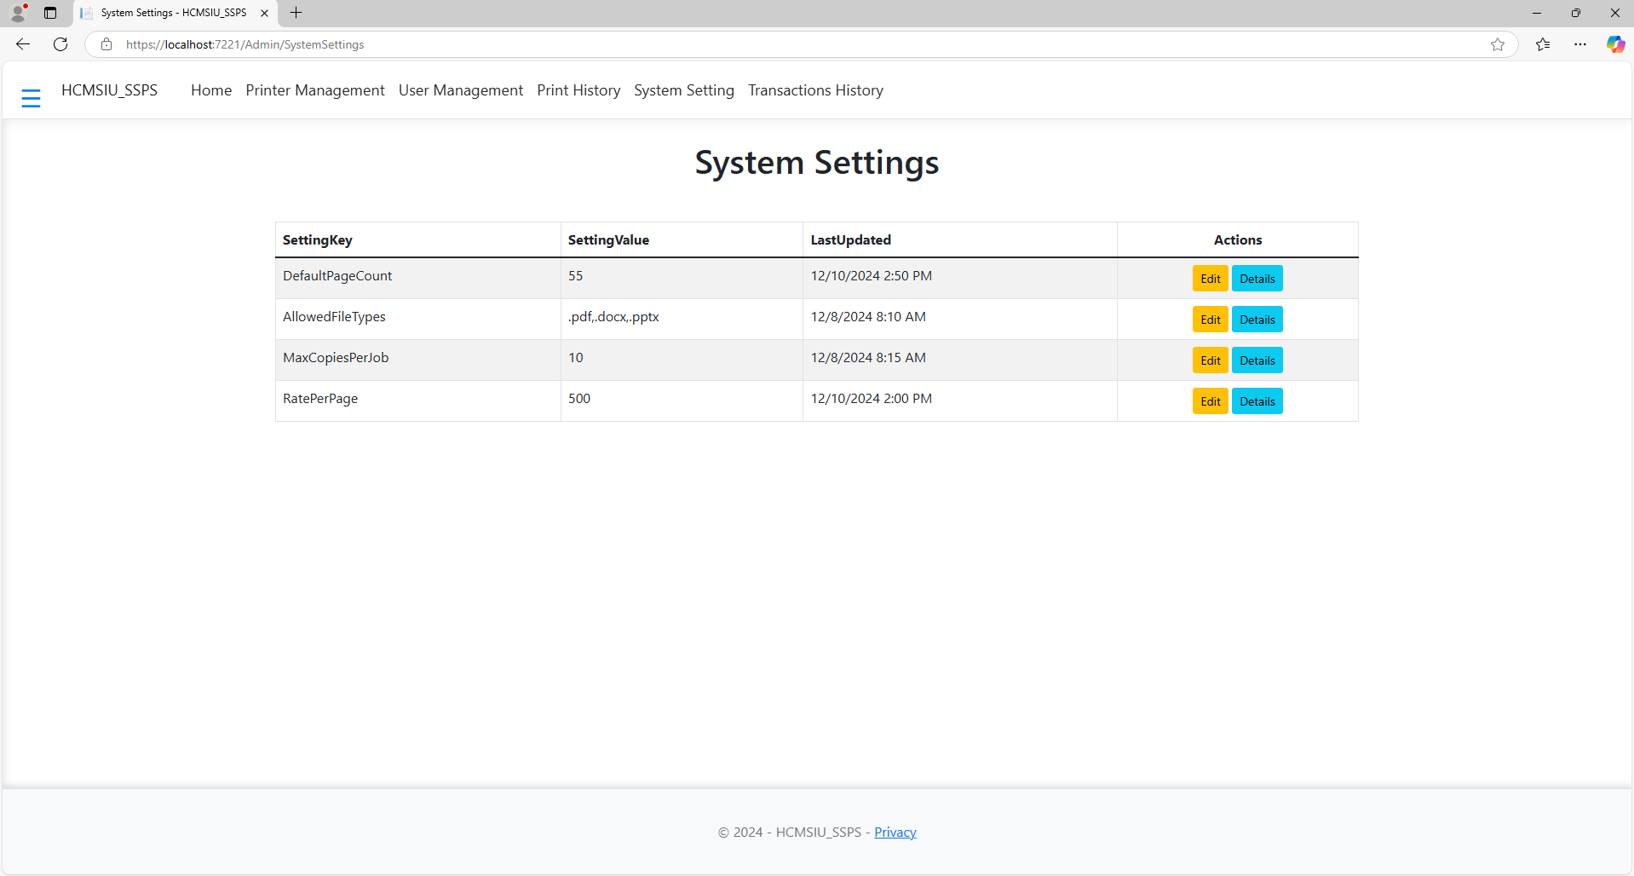

*2.2.19. System editing interface*

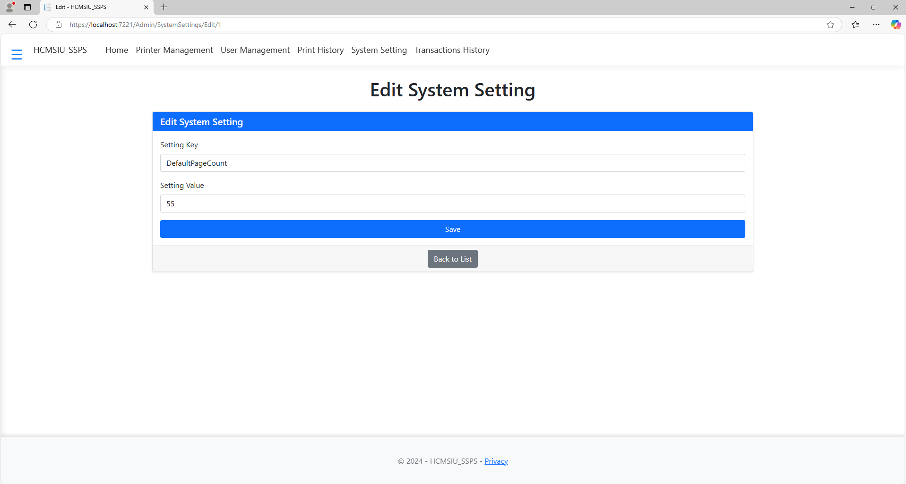

*2.2.20. System detail interface*

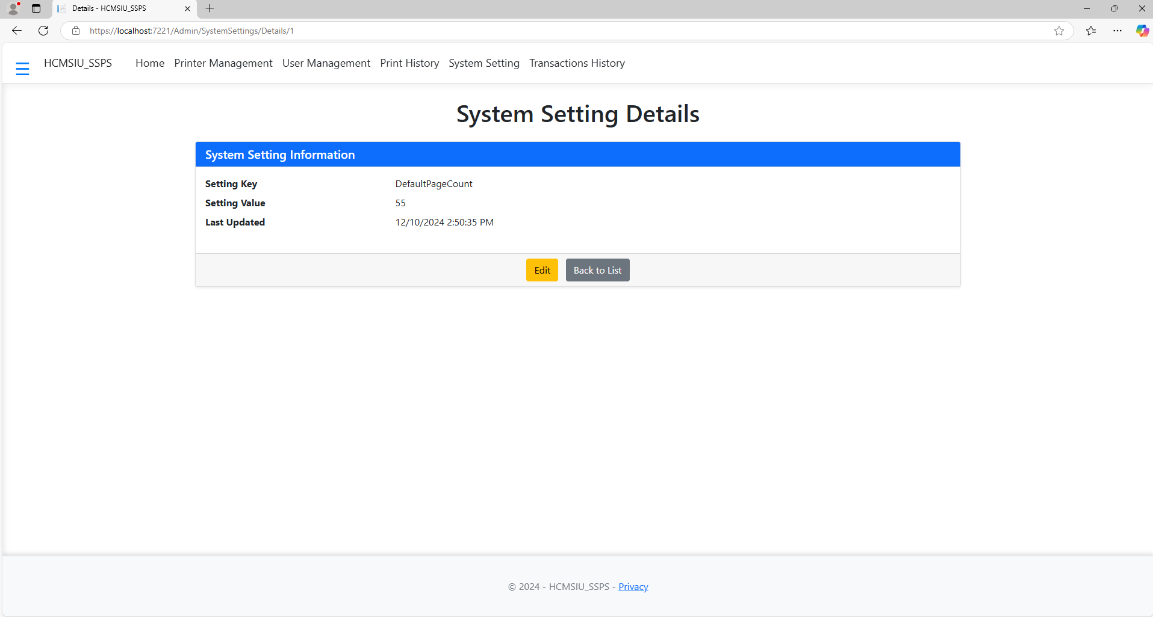

*2.2.21. System usage report management interface*

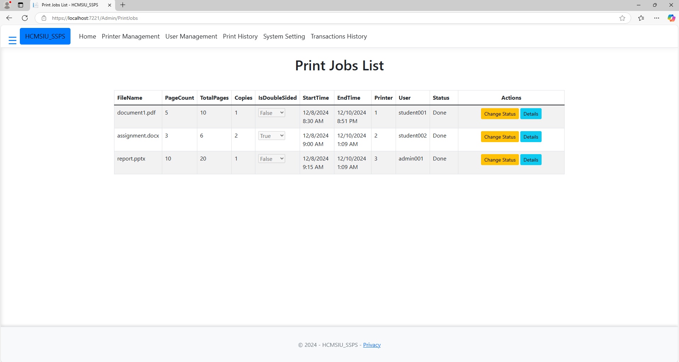

*2.2.22. Report detail interface*

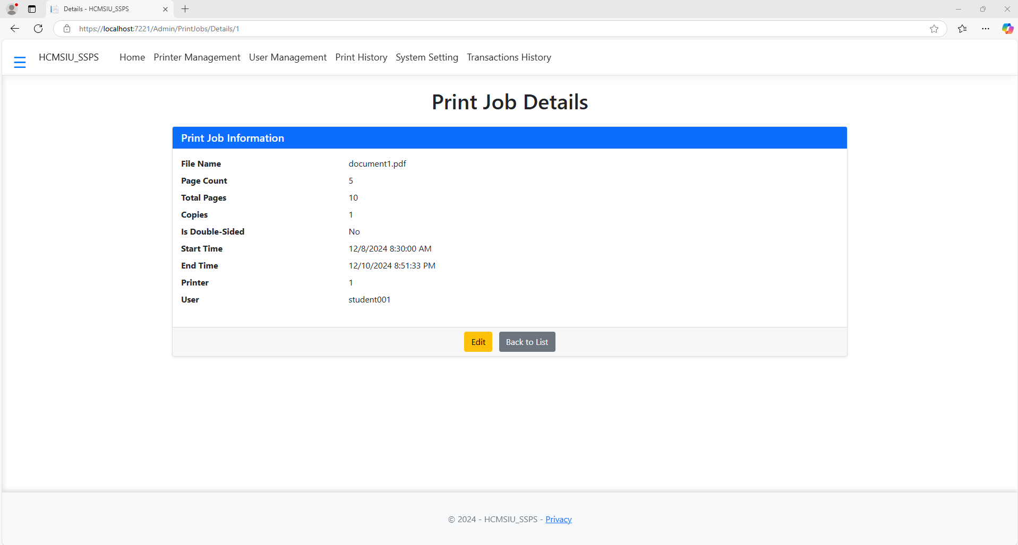

*2.2.23. Transaction history management interface*

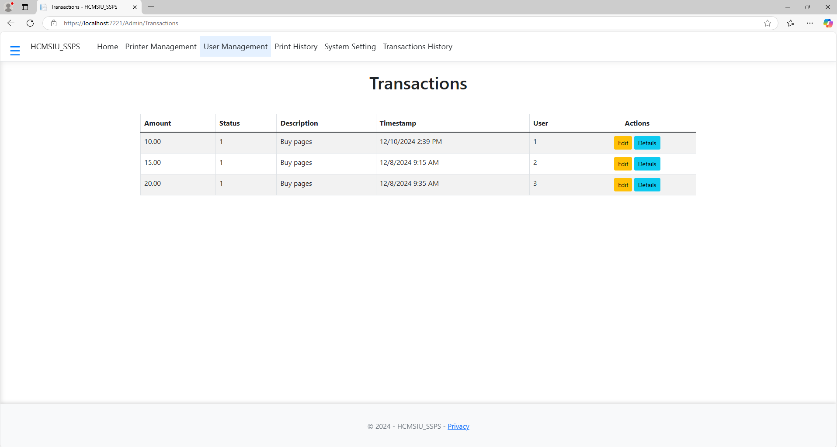

*2.2.24. Transaction editing interface*

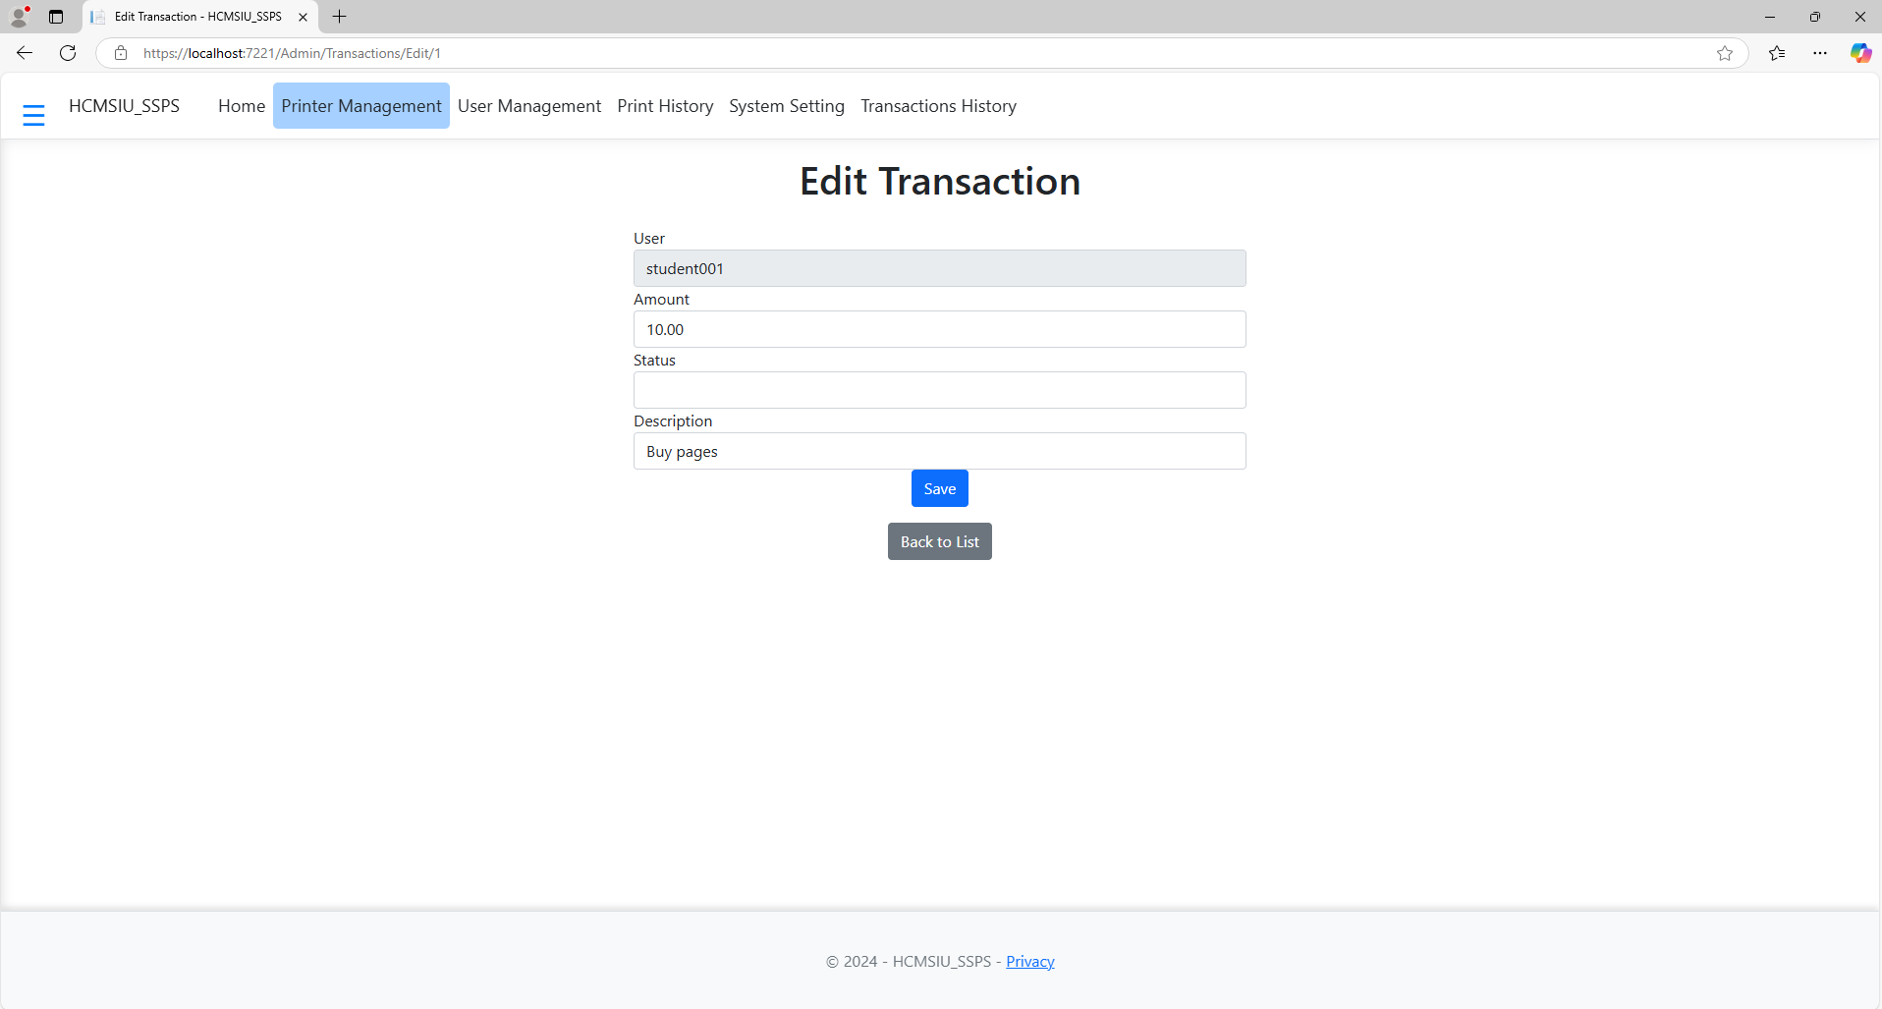

*2.2.25. Transaction detail interface*

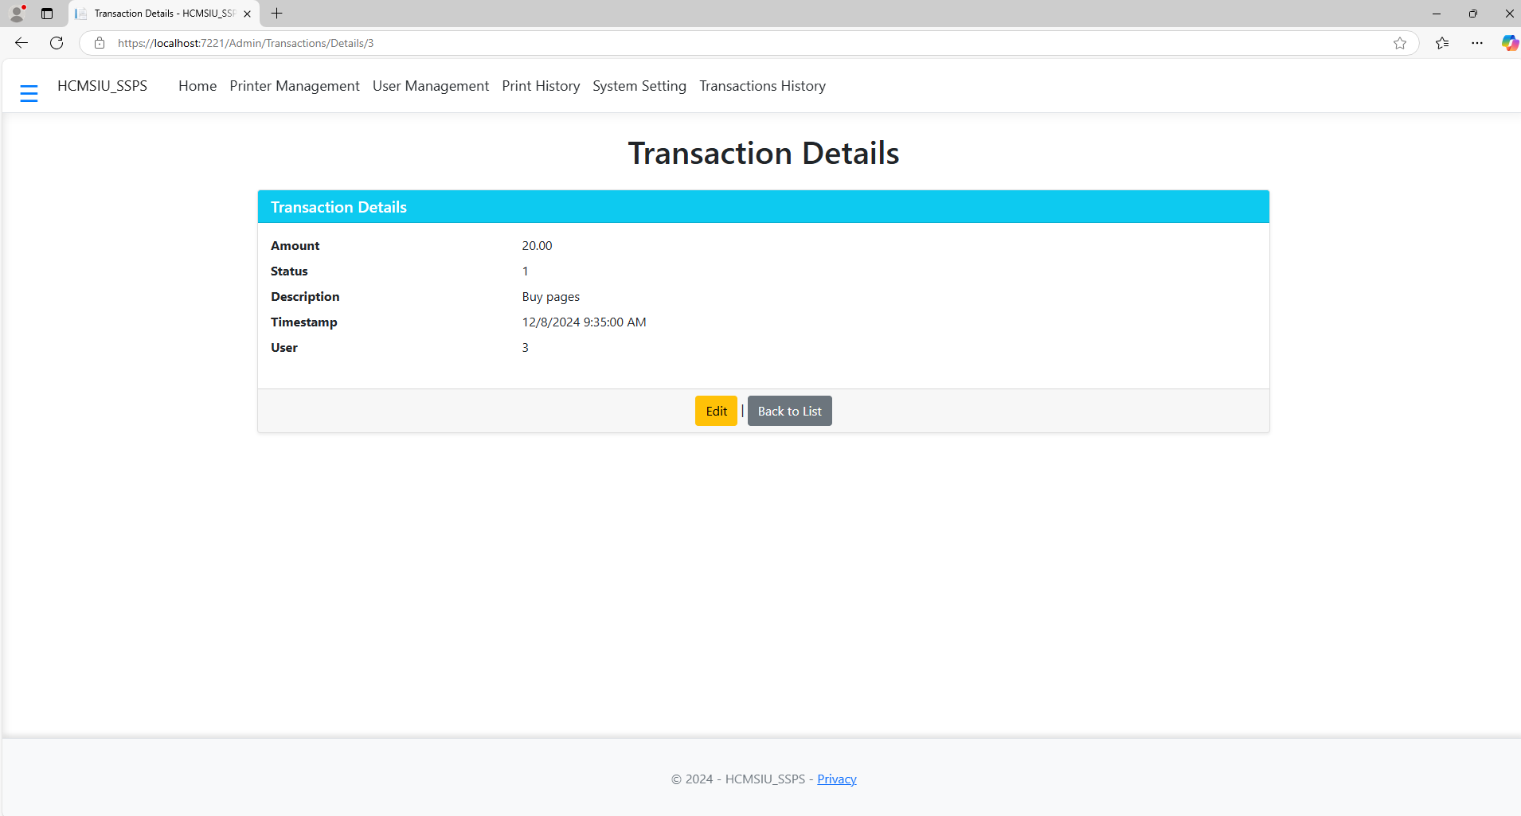

### 3. Testing

**Test Board:**

3.1. Login function

|  |  |  |  |  |  |  |  |
| --- | --- | --- | --- | --- | --- | --- | --- |
| **ID** | **Test Case Name** | **Preconditions** | **Test Steps** | **Expected Result** | **Actual Result** | **Status** | **Remarks** |
| TC001 | Người dùng đã đăng ký tài khoản | 1. Mở ứng dụng.  2. Nhập tên đăng nhập và mật khẩu hợp lệ.  3. Nhấn nút Đăng nhập. | Người dùng được chuyển đến trang chủ. |  |  | Passed/Failed |  |
| TC002 | Người dùng đã đăng ký tài khoản | 1. Mở ứng dụng.  2. Nhập tên đăng nhập hoặc mật khẩu sai.  3. Nhấn nút Đăng nhập. | Hiển thị thông báo lỗi "Tên đăng nhập hoặc mật khẩu không đúng." |  |  | Passed/Failed |  |
| TC003 | Đăng nhập với tài khoản chưa đăng ký | 1. Mở ứng dụng.  2. Nhập tên đăng nhập chưa đăng ký.  3. Nhấn nút Đăng nhập. | Hiển thị thông báo lỗi "Tài khoản không tồn tại." |  |  | Passed/Failed |  |

3.2. Logout function

|  |  |  |  |  |  |  |  |
| --- | --- | --- | --- | --- | --- | --- | --- |
| **ID** | **Test Case Name** | **Preconditions** | **Test Steps** | **Actual Result** | **Expected Result** | **Status** | **Remarks** |
| TC004 | Đăng xuất khi đang đăng nhập | 1. Mở ứng dụng.  2. Nhập tên đăng nhập và mật khẩu hợp lệ.  3. Nhấn nút Đăng nhập. | Người dùng đã đăng nhập |  |  | Passed/Failed |  |

3.3. Forgot Password function

|  |  |  |  |  |  |  |  |
| --- | --- | --- | --- | --- | --- | --- | --- |
| **ID** | **Test Case Name** | **Preconditions** | **Test Steps** | **Expected Result** | **Actual Result** | **Status** | **Remarks** |
| TC005 | Quên mật khẩu với email hợp lệ | 1. Nhấn vào "Quên mật khẩu".  2. Nhập email đã đăng ký.  3. Nhấn nút "Gửi yêu cầu". | Người dùng đã đăng nhập | Email khôi phục mật khẩu được gửi đến người dùng. |  | Passed/Failed |  |
| TC006 | Quên mật khẩu với email không hợp lệ | Người dùng chưa đăng ký tài khoản | 1. Nhấn vào "Quên mật khẩu".  2. Nhập email chưa đăng ký.  3. Nhấn nút "Gửi yêu cầu". | Hiển thị thông báo lỗi "Email không tồn tại." |  | Passed/Failed |  |

3.4. Print Command Function

|  |  |  |  |  |  |  |  |
| --- | --- | --- | --- | --- | --- | --- | --- |
| **ID** | **Test Case Name** | **Preconditions** | **Test Steps** | **Expected Result** | **Actual Result** | **Status** | **Remarks** |
| TC007 | Tạo lệnh in với thông tin hợp lệ | Người dùng đã đăng nhập và có tài khoản in | 1. Mở trang tạo lệnh in.  2. Chọn loại tài liệu cần in.  3. Nhập thông tin cần thiết.  4. Nhấn "Tạo lệnh in". | Lệnh in được tạo thành công và hiển thị trên danh sách lệnh in. |  | Passed/Failed |  |

3.5. Print History View Function

|  |  |  |  |  |  |  |  |
| --- | --- | --- | --- | --- | --- | --- | --- |
| **ID** | **Test Case Name** | **Preconditions** | **Test Steps** | **Expected Result** | **Actual Result** | **Status** | **Remarks** |
| TC008 | Xem lịch sử in của người dùng | Người dùng đã đăng nhập và có lịch sử in và có tài khoản in | 1. Mở trang "Lịch sử in".  2. Xem danh sách các lệnh in đã thực hiện. | Danh sách lịch sử in hiển thị đúng thông tin. |  | Passed/Failed |  |
| TC009 | Xem lịch sử in khi không có dữ liệu | Người dùng chưa thực hiện lệnh in nào | 1. Mở trang "Lịch sử in".  2. Kiểm tra xem có dữ liệu hiển thị. | Hiển thị thông báo "Chưa có lệnh in nào." |  | Passed/Failed |  |

3.6. Buy Print Page Function

|  |  |  |  |  |  |  |  |
| --- | --- | --- | --- | --- | --- | --- | --- |
| **ID** | **Test Case Name** | **Preconditions** | **Test Steps** | **Expected Result** | **Actual Result** | **Status** | **Remarks** |
| TC010 | Mua trang in với số lượng hợp lệ | Người dùng đã đăng nhập và có tài khoản in | 1. Chọn chức năng mua trang in.  2. Nhập số lượng trang in cần mua.  3. Nhấn "Mua". | Thông báo xác nhận mua thành công và số dư được cập nhật. |  | Passed/Failed |  |
| TC011 | Mua trang in với số lượng | Người dùng đã đăng nhập và có tài khoản in | 1. Chọn chức năng mua trang in.  2. Nhập số lượng trang in không hợp lệ (ví dụ: số lượng = 0).  3. Nhấn "Mua". | Hiển thị thông báo lỗi "Số lượng |  | Passed/Failed |  |

3.7. Printer Management Function

|  |  |  |  |  |  |  |  |
| --- | --- | --- | --- | --- | --- | --- | --- |
| **ID** | **Test Case Name** | **Preconditions** | **Test Steps** | **Expected Result** | **Actual Result** | **Status** | **Remarks** |
| TC012 | Thêm máy in mới | Người dùng đã đăng nhập và có quyền quản lý máy in | 1. Mở trang quản lý máy in.  2. Nhấn "Thêm máy in".  3. Nhập thông tin máy in (Tên, Mã máy, Vị trí, ...).  4. Nhấn "Lưu". | |  |  | | --- | --- | | Máy in mới được thêm vào danh sách quản lý máy in. |  | |  | Passed/Failed |  |
| TC013 | Sửa thông tin máy in | Máy in đã được thêm vào hệ thống và có tài khoản in | 1. Mở trang quản lý máy in.  2. Chọn máy in cần sửa.  3. Cập nhật thông tin máy in.  4. Nhấn "Lưu". | Thông tin máy in được cập nhật thành công. |  | Passed/Failed |  |

3.8. Student Account Management Function

|  |  |  |  |  |  |  |  |
| --- | --- | --- | --- | --- | --- | --- | --- |
| **ID** | **Test Case Name** | **Preconditions** | **Test Steps** | **Expected Result** | **Actual Result** | **Status** | **Remarks** |
| TC015 | Thêm tài khoản sinh viên | Người dùng có quyền quản lý tài khoản sinh viên | 1. Mở trang quản lý tài khoản sinh viên.  2. Nhấn "Thêm tài khoản".  3. Nhập thông tin tài khoản sinh viên.  4. Nhấn "Lưu". | |  |  | | --- | --- | | Tài khoản sinh viên được thêm vào hệ thống. |  | |  | Passed/Failed |  |
| TC016 | Sửa thông tin tài khoản sinh viên | Tài khoản sinh viên đã tồn tại trong hệ thống | 1. Mở trang quản lý tài khoản sinh viên.  2. Chọn tài khoản cần sửa.  3. Cập nhật thông tin tài khoản.  4. Nhấn "Lưu". | Thông tin tài khoản sinh viên được cập nhật thành công. |  | Passed/Failed |  |

3.9. System Usage Report Management Function

|  |  |  |  |  |  |  |  |
| --- | --- | --- | --- | --- | --- | --- | --- |
| **ID** | **Test Case Name** | **Preconditions** | **Test Steps** | **Expected Result** | **Actual Result** | **Status** | **Remarks** |
| TC017 | Xem báo cáo sử dụng hệ thống | Người dùng có quyền xem báo cáo | 1. Mở trang báo cáo sử dụng hệ thống.  2. Chọn loại báo cáo cần xem.  3. Nhấn "Lọc". | |  |  | | --- | --- | | Báo cáo sử dụng hệ thống được hiển thị đúng theo yêu cầu. |  | |  | Passed/Failed |  |
| TC018 | Lọc báo cáo theo thời gian | Người dùng có quyền xem báo cáo | 1. Mở trang báo cáo sử dụng hệ thống.  2. Chọn khoảng thời gian cần lọc.  3. Nhấn "Lọc". | Báo cáo được lọc theo thời gian chính xác. |  | Passed/Failed |  |

3.10. Print History View and Management Function

|  |  |  |  |  |  |  |  |
| --- | --- | --- | --- | --- | --- | --- | --- |
| **ID** | **Test Case Name** | **Preconditions** | **Test Steps** | **Expected Result** | **Actual Result** | **Status** | **Remarks** |
| TC019 | Xem lịch sử in | Người dùng đã đăng nhập | 1. Mở trang "Lịch sử in".  2. Xem danh sách các lệnh in đã thực hiện. | Lịch sử in hiển thị chính xác các lệnh in đã thực hiện. |  | Passe  d/Failed |  |
| TC020 | Lọc báo cáo theo thời gian | Người dùng có quyền xem báo cáo | 1. Mở trang báo cáo sử dụng hệ thống.  2. Chọn khoảng thời gian cần lọc.  3. Nhấn "Lọc". | Báo cáo được lọc theo thời gian chính xác. |  | Passed/Failed |  |

3.11. System Configuration Management Function

|  |  |  |  |  |  |  |  |
| --- | --- | --- | --- | --- | --- | --- | --- |
| **ID** | **Test Case Name** | **Preconditions** | **Test Steps** | **Expected Result** | **Actual Result** | **Status** | **Remarks** |
| TC021 | Cập nhật cấu hình hệ thống | Người dùng có quyền quản lý cấu hình | 1. Mở trang quản lý cấu hình hệ thống.  2. Chỉnh sửa các cấu hình cần thiết.  3. Nhấn "Lưu". | |  |  | | --- | --- | | Cấu hình hệ thống được cập nhật thành công Cấu hình hệ thống được cập nhật thành công |  | |  | Passed/Failed |  |
| TC022 | Khôi phục cấu hình mặc định | Người dùng có quyền quản lý cấu hình | 1. Mở trang báo cáo sử dụng hệ thống.  2. Chọn khoảng thời gian cần lọc.  3. Nhấn "Lọc". | Cấu hình hệ thống được khôi phục về mặc định |  | Passed/Failed |  |

3.12. Payment Configuration Management Function

|  |  |  |  |  |  |  |  |
| --- | --- | --- | --- | --- | --- | --- | --- |
| **ID** | **Test Case Name** | **Preconditions** | **Test Steps** | **Expected Result** | **Actual Result** | **Status** | **Remarks** |
| TC023 | Cập nhật cấu hình thanh toán | Người dùng có quyền quản lý | 1. Mở trang quản lý cấu hình thanh toán.  2. Chỉnh sửa các thông tin thanh toán (cổng thanh toán, loại tiền tệ, ...).  3. Nhấn "Lưu". | |  |  | | --- | --- | | Cấu hình thanh toán được cập nhật thành công. |  | |  | Passed/Failed |  |
| TC024 | Khôi phục cấu hình thanh toán mặc định | Người dùng có quyền quản lý cấu hình thanh toán | 1. Mở trang quản lý cấu hình thanh toán.  2. Nhấn "Khôi phục mặc định".  3. Xác nhận khôi phục. | Cấu hình thanh toán được khôi phục về mặc định |  | Passed/Failed |  |

## CHAPTER 4: CONCLUSION AND DEVELOPMENT DIRECTION

### 1. Conclude

**1.1. Evaluate the results**

Can use C# language to build a website and know how to use MySQL database.

**1.2.** **Function has been done**

Deploy a relatively complete software with basic functions of a software.

Ensure Admin login to be able to manage the part easily.

Ensure usage rights, privacy and security of each user's information.

### 2. Development direction

In the future, our group will focus on developing to complete the missing functions in the unfinished functions section. At the same time, upgrade the interface of the main page of the Admin section to be more modern and have more convenient functions.

**2.1. Complete and add functions**

Develop more advanced functions such as more detailed user management, statistical reports, and data analysis tools.

Integrate new technologies such as AI and Machine Learning to optimize user experience and improve system performance.

Expand the content management system (CMS) to allow administrators to easily add, edit, and delete content on the website.

**2.2. Interface upgrade**

Redesign the user interface (UI) to be more user-friendly, creating a better user experience (UX).

Use modern UI frameworks and libraries such as React or Angular to increase interactivity and dynamism for the website.

Improve responsiveness so that the website works smoothly on different devices such as computers, tablets and mobile phones.

**2.3. Enhanced security**

Apply advanced security methods such as two-factor authentication (2FA) to protect user accounts.

Improve the system to detect and prevent cyber attacks such as SQL Injection, Cross-Site Scripting (XSS), and Distributed Denial-of-Service (DDoS). Regularly update and patch the system to ensure information security for users.

With these developments, the team hopes to not only improve software quality but also enhance user experience, better meeting the requirements and expectations of users in the future.